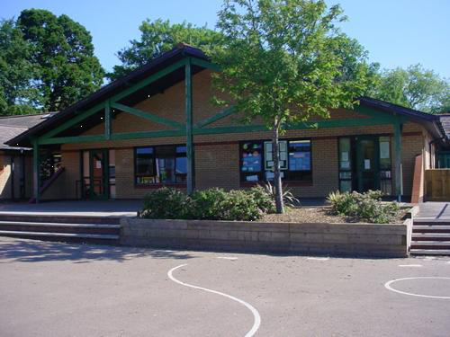

**Numeracy** Know and understand place value, ordering and rounding. Use basic number facts to help add and subtract. Count on and back in 10s and use number sequences. Understand addition and subtraction and use mental calculation strategies. Count on from a given number and understand properties of numbers. Understand multiplication and use number facts to help. Estimating and checking ..Measure on a ruler, use cm and mm. Work with data. Use > and <

**Innovate – Let’s get creative!**

Using resources make a giant digestive system. Working with in a group children will design and create a working model.

**RE/SEAL**

* New Beginnings
* Harvest
* Festivals of light

**Welsh:** Holiday News

Hold a telephone conversation

Read a Welsh book **: Yn y Goedwig yn y Nos**

**Homework**

1. Keep a food diary for 3 weeks.

2. Make a list of well known idioms

3. Time length of time spent brushing teeth daily

4. Try a new drink or food you’ve never tasted before and tell the class about it.

5. Design a healthy menu for your teachers.

**BURPS, BOTTOMS AND BILE**

**YEARS 3 & 4**

**Science Investigations**

* What is spit for?
* How does toothpaste protect teeth?

**PE**

* Invasion Games (rugby/netball)
* Gymnastics (sequences)

**Express**

Write a persuasive text to encourage people to change their eating habits to care for their teeth and digestive systems. Make a video and script about digestive system. Design healthy snack packs. Create a class song about bodily functions.

**Develop** Explore and learn about idioms relating to teeth. Write explanation about tooth decay using idioms. Using animation to create a story of the digestive system. To create a persuasive PowerPoint using slogans on a healthy bowel. To learn about the steps of digestion.

**Engage** :

Meet local dentist, look at range of teeth and dental procedures.

To remember facts and information.

To select leaflets and flyers to take back to school to read.

Learn key dental vocabulary.

Take part in a dental examination.

Research in class.

**Literacy**

* Dilemma Stories
* Adjectives, similes, metaphors
* Direct speech – inverted commas
* Story settings
* Journalistic recounts
* Who, Where, When, Why, What?
* Organisational Features