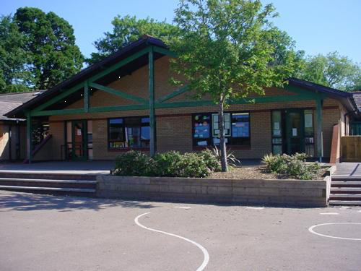

**Homework**

* **Talk to members of your family to find out changes that have occurred since they were 10. Is the World a better place now?**

**\* Create a time line for your family showing important events eg births, marriages, house moves. This could include photos.**

**\* If you could time travel to any time and any place in the World, where would you go? Make a scrap book of your adventure showing what you would do while you were there.**

**\* Complete a survey to find out which aspect of technology would be missed most.**

**\* Draw and label a design for a product of the future.**

**1**

**Science**

**Find out about puberty.**

**Identify the key stages of human development from birth to old age.**

**PE**

**Skills based team games and Dance.**

**RE/SEAL**

**New beginnings. Celebration of differences and similarities. Exploring belonging to a group. Learning conditions. Starting new things.**

**Putting faith into practice / Why care for others?**

**Focus on Christianity & Sikhism.**

**Develop**

**Solve a range of time related problems.**

**Investigate how an aspect of everyday life has changed over the past 200 years and display as a chronological time line.**

**Collect and analyse data on temperature through a day.**

**Design and make a clock.**

**Research the current UK population.**

**Numeracy**

**Sequence of number – counting backwards**

**and forwards in hundreds, tens and tenths.**

**Place Value - partitioning, rounding, 10/100 times bigger smaller. Halving. Tables. Decimals. Mental and written calculations – Simple proportions. Fractions. Percentages. Doubling diamond. Addition techniques. Subtraction. Multiplication methods.**

**Literacy**

**Fiction: Myths and legends.**

**Non-fiction: Instructional texts.**

**Read write inc. spelling scheme.**

**Handwriting – joined.**

**Group reading exercises.**

**Book reviews.**

**Engage**

**Create a character study by looking at photographs and collecting a range of interesting adjectives to describe them.**

**Using personal photos from home build up a time line of their lives.**

**Make a digital montage of themselves in the style of Andy Warhol’s ‘Marilyn Monroe’ prints.**

**Talk to people in the community about local changes they have seen over the years.**

**Welsh**

**Talking, reading & writing about themselves and others in the present and past tense.**

**Expressing opinions about books. Telling the time.**

**Express**

**Use mixed media to create a collage that reflects their hope and dreams for the future.**

**Look at quotes about time and create a collaborative poem including similes and metaphors.**

**Time Travellers.**



**Year 5.**