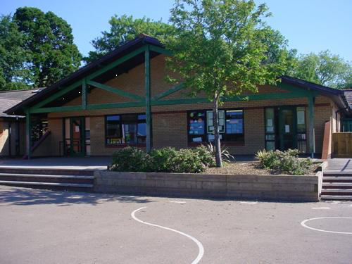

**Misty Mountain Sierra**

**Years 3 and 4**

**Expressive Arts**

Advent and Christmas art and craft

Christmas performance

Create a 3D model of a mountain

Make a photo diary of a mountain walk

Compose music for a 2D animation

Look at geometric patterns in Adi

**Humanities**

Write an information booklet mountain formation

Use atlases to locate significant mountains.

Visit Blaenavon mountainside

Record information including photo graphs, drawings and notes about the landscape, flora and fauna.

Explore contour maps

Find out about geocaching

**Welsh**

Hwyl y Gaeaf (Winter Wonderland) vocabulary and phrases

Nadolig

**Science and Technology**

Where does water go?

Why does it flood?

Create a mini water cycle and investigate how water changes state.

**Homework**

1. Write an information booklet explaining mountain formation

2. Create a 3D model of a mountain

3. Make a photo diary of a mountain walk

4. Write a water cycle song or rap to perform

5. Research the survival of animals living in mountainous areas.

2.

3.

4.

5.

**Health and Wellbeing**

Getting on and Falling Out

Say No to Bullying

Find out about the charity, *Mountain Rescue.*

Invasion Games (rugby/netball)

Swimming

**Maths and Numeracy**

Discover the heights of some of the world’s significant mountains

Present data in tables and graphs

Make comparisons

Multiplication tables

Written calculations

Maths reasoning problems

**Language, Literacy and Communication**

Reports and Recounts

Poetry on mountains (calligrams)

Explanations

Make notes and produce a leaflet

Atmospheric descriptions

Mountaineering narratives

Present to class and field questions..