[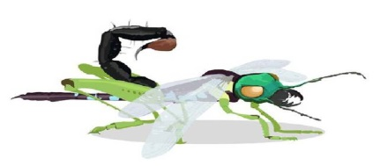](http://www.google.co.uk/url?sa=i&rct=j&q=&esrc=s&source=images&cd=&cad=rja&uact=8&ved=0ahUKEwjJ9sHctfrYAhWHUlAKHcXZBZoQjRwIBw&url=http://www.mylearning.org/minibeasts/images/2-208/&psig=AOvVaw26kKQR3lV0thSCksebNUJ-&ust=1517220705528184)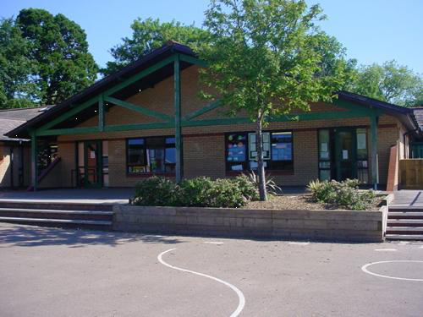

Maths and Numeracy

Divide a 3 digit no by a single digit no – chunking on no line. Division using subtraction with vertical format. Multiply and divide numbers and decimals by 10 and 100. Calculate fractional quantities. Add and subtract 3-digit numbers using an appropriate mental or written method. Check answers using inverse operations. Order negative and positive numbers including decimals to 1 decimal place. Multiply and divide a 3 digit number by a single digit. Estimate by rounding to the nearest 10, 100 or 1000. Congruent shapes. Volume. Algebra.

**Topic -**

Investigate ways of presenting minibeast data**.**

***BEAST CREATOR***

***YEAR FIVE - Swifts***

**Homework**

1.Go on a bug hunt in your garden, a local park or woodland. What did you find? Draw pictures or photograph your finds. Can you use books or the internet to identify your finds?

2.Use dough or clay to make a replica of your favourite minibeast.

3.Use paints to design a beautiful and symmetrical design for a butterfly’s wing. Can you transfer your design to a computer?

4.If you were an insect for a day what kind would you be? Why? Where would you live? How safe would you be from predators? Write your story!

5.Visit a local museum (Cardiff is good) and find out more about minibeasts.

**Science and Technology**

Food chains and webs.

Find out about a life cycle of a minibeast.

Find out which minibeasts feed on the common aphid. What sort of people find the common aphid a nuisance? Why would a super strong aphid be a bigger problem?

Selective breeding – what is it? Create your own super beast to control the super aphids.

**Language, Literacy and Communication**

**Language and Literacy -**

Persuasive letter writing.

Stories by significant children’s authors.

Biography and autobiography

**Topic -**

Draft and produce a word processed non-chronological report for an Encyclopaedia on your super bug.

Write a set of instructions showing how to make a model.

Write an advertisement for your super bug.

**Welsh**

Merched Beca

Bwsytfil 1-4

Rap ailgylchu

Compost arbennig

**Expressive Arts**

Draw a detailed picture of part of a minibeast.

Create your own mini beast, using different materials and media.

**Health and Wellbeing**

Going for Goals (SEAL).

Good to be me (SEAL).

Stick and ball games (striking and hitting)

Skills based team games.

Gymnastics.

**Humanities**

Produce a scale map of the World.

Create Deadly creatures top trump cards on minibeasts from round the world.

Believing and doubting - To consider feelings such as faith, trust, doubt and reflect on how these have been expressed by religious figures & present day faith adherents.