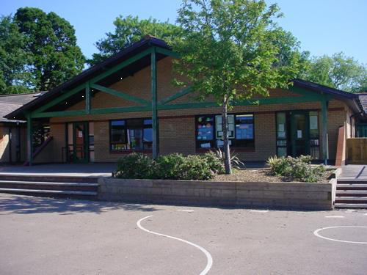

**Homework**

1. Make a World War Two scrapbook using images and captions.
2. Make a gas mask box and evacuee label.
3. Pack a shoe box of some of your favourite items you would take as an evacuee.
4. Make a fact file about Winston Churchill.

**Humanities**

Listen to the sounds of World War Two (air raid sirens, bombing, spitfires).

Imagine being an evacuee, what would it feel like?

Look at areas affected by large-scale bombing. Why did the Germans target these areas?

Discuss the diary of Anne Frank

**Language, Literacy and Communication**

**Language and Literacy**: Unit 4

Fiction: (A story with flashbacks)

‘Gone Away!’ by Lou Kuenzler

Non-Fiction: (Biography/autobiography)

‘Alexander Selkirk biography’

**Welsh**

Merched Beca – Understanding a school play.

Learn parts of the body

Describe a monster – Write a paragraph to show their understanding

**Expressive Arts**

Discuss war time rationing and how foods were different.

Pupils will make a few favourite foods following the methods and using the ingredients.

Learn the song ‘Pack up your troubles’ Why is it a happy song even though it is about a soldier going to war? Introduce to some alternatives too.

**A Child’s War**

**YEAR 6**

**Maths and Numeracy**

Co-ordinates: Pupils will learn to plot co-ordinates across 4 quadrants whilst also reflecting and translating shapes.

Multiplying decimals: 0.4 x 16.

Use numbers to represent the likelihood of an event.

Extract and interpret information from line/bar graphs.

Identify lines of symmetry between a given shape and regular polygons.

**Health and Wellbeing**

PE – indoor – circuit training

PE – outdoor – football/netball

Hold class discussion on the questions ‘how would you feel about welcoming an evacuee into your home?’

How did it feel to return home?

**Science and Technology**

Database input and understanding of filtering

How does inheritance work?

Children investigate how offspring inherit traits from their parents.

What’s in blood?

Children learn what is in blood and how it carries oxygen, water, nutrients and waste products around the body.