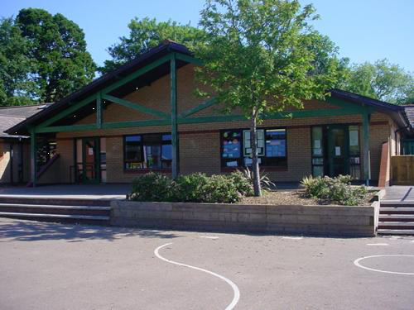

**Numeracy**

Consolidation of numeracy skills in addition, subtraction, multiplication and division

Revision of different ways of solving problems

Approaches to numerical reasoning

Estimation and checking

Standard units of measure (cm, g, ml )

**Innovate – Let’s get creative!**

Make clay gifts.

Tell stories around the campfire.

Explore Celtic craft and art work.

Make mini roundhouses, exploring suitable materials.

**Literacy**

*Fiction* writing mystery stories with suspense

*Non- Fiction* skim to gain an overview, record key facts & information, use vocabulary related to the topic

*Grammar* Adverbs, word families, similes, spelling patterns

**Develop**

Learn about the Druids

Participate in an Iron Age fashion show

Compare life of 2017 child with Iron Age child

Explore Celtic craft and patterns

Follow an Iron Age recipe – compare taste, flavour and appearance with bread today

**Homework Opportunities**

Design a poster or fact file to show your research about the female Celtic Warriors!

Write a diary entry imaging you are a Celtic Farmer titled ‘My Typical Day’

Research using the web to find out about Celtic hoards and treasures found in Wales

What does an archaeologist do? Find out and be prepared to tell the class with a short presentation!

Create a quiz about Iron Age Celts – Quizlet is a great app to try to learn to use!

**Express**

Discover the Romans and what happened during the Roman Invasion.

Explore the relationship between the Celts and the Romans and how life began to change.

**Engage**

History Skills – research who the Iron Age people (aka Celts) were

Explore living conditions, daily routines, war, illness, medicines and lots more

**TRIBE! YEAR 3**

**PE**

Warrior re-enactment in Creative Dance

Ball skills and creative games

**RE/SEAL**

Judaism is our key focus in RE this term

SEAL - Relationships

**Welsh**

Hobbies, reading texts and asking questions, being able to write and express opinions, write a simple recount on a post card

**Science Investigations**

How waterproof are certain materials?

How have ‘Iron Age bog bodies’ been preserved? *(soil acidity)*