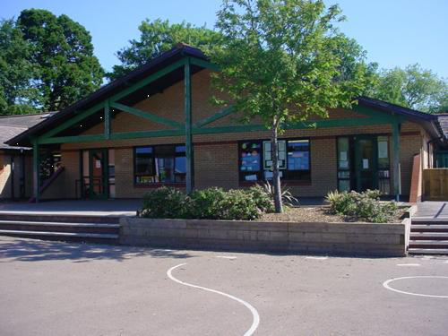

**Literacy**

* **Stories with historical settings**

Descriptive words, special phrases, standard English, first person, past tense, punctuation of speech.

* **Newspapers**

Organisational features – headlines, caption, columns. Complex sentences, attention grabbing language, use of synonyms to avoid repeating words

**Welsh**

Discuss the weather

Simple map reading and promoting the area

Perform a rap and learn and sing ***Sospan Fach***Compare and contrast life in the 21st century with that in the Tudor period.

**Create and perform a new rap /**

**Learn and sing the Welsh folksong Sosban Fach**

**Science Investigations**

* Did the Romans use toilets?
* How far can an arrow travel?
* What are catapults for?

**Develop**

* Investigate forces – design a roman aqueduct.
* Study the geography of a Roman fort, specifically Caerleon.
* Read , write and calculate with Roman numerals
* To try a range of Roman food

**Numeracy**

**Mathematical Development**

**Count** in 6s. Count in 25s, 50s and 250s (link to work with scales) Count forwards and backwards from any 3-digit number focusing on ‘tricky bridges’

Find 1/10 of whole numbers by dividing by 10 **Compare and estimate** with numbers up to

Consolidate complements of 100, £10 and 1Identify numbers that are multiples of 50 and 100.

**Recognise connections** between fractions.

**Multiply** a 3 digit number by a single digit number using the grid method.

**Symmetry, data** from charts, timetables, graphs

**Compass points, weights and measures, time , coordinates** and **reflection.**

**Engage**

* Artefacts and activities provided by Monmouth museum.
* Asking questions about the past.
* Looking at timelines to sequence events.

**Express**

* Study the end of Roman rule and write an explanation.
* Investigate how Latin influenced Welsh and English language.
* Write the top 10 things the Romans did for us.

**PE**

* Fielding and striking – cricket, rounders.
* Athletics – running, throwing, relay, jumping.

**RE/SEAL**

* Whose World? – Christianity and Buddhism
* Relationships

**Innovate – Let’s get creative!**

* Design a Roman shield.
* Practise being a Roman soldier

**The Romans are Coming**

**YEAR FOUR**

**Homework**

1. Create a factfile about a Roman god?
2. Design and make a Roman helmet.
3. Create a Roman scroll - draw Roman numerals upon it.
4. Create a Roman alphabet – one word per letter.
5. Visit or research a Roman site in Wales eg. Caerleon, Gelligaer.