**RE/SEAL**

**SEAL – Good to be me.**

**(Genetic engineering debate.)**

**RE - Believing & doubting.**

**To consider feelings such as faith, trust, doubt and reflect on how these have been expressed by religious figures & present day faith adherents.**

**Welsh**

**Talking about music preferences.**

**Finding out about the Tudors. What did they eat, wear and drink?**

**The weather.**

Year 5.

Beast Creator.

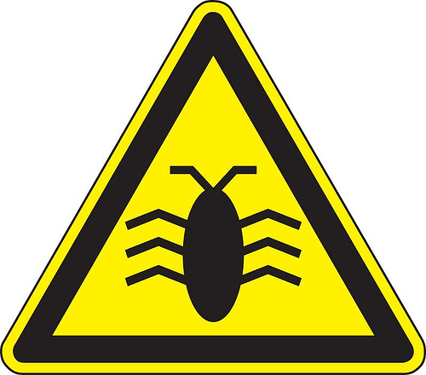

**Inovate & Express**

**Find out which minibeasts feed on the common aphid. What sort of people find the common aphid a nuisance? Why would a super strong aphid be a bigger problem? Selective breeding – what is it? Create your own super beast to control the super aphids.**

**Engage**

**Draw a detailed picture of part of a minibeast.**

**Draft and produce a word processed non-chronological report for an Encyclopaedia on your super bug.**

**Investigate ways of presenting minibeast data**

**Literacy**

**Studying stories from other cultures.**

**Writing an adventure story.**

**Writing a non-chronological report.**

**Handwriting.**

**Read and write reviews of books.**

**Spelling strategies.**

**Reading and writing Limericks and Kennings.**

**Science**

**Food chains and webs.**

**Find out about a life cycle of a minibeast.**

**Numeracy: Revision of...**

**Sequence of number – counting backwards and forwards in a variety of multiples within 10. Number systems –Reading, writing and ordering numbers to 100,000. Tables. Multiplying & dividing by 10 & 100. Rounding. Mental and written calculations – calculating fractional quantities. Adding, subtracting, multiplying and dividing 3 digit numbers and decimals.**

**Other areas – Multistep function machines. Congruent shapes, Translation, reflection and rotation of shapes. Mean, median mode and range. Volume. Basic algebra. Investigations.**

**PE**

**Swimming / Bench ball.**

**Athletics.**

**Develop**

**Produce a scale map of the World.**

**Create Deadly creatures top trump cards on minibeasts from round the world.**

**Write a set of instructions showing how to make a model.**

**Write an advertisement for your super bug.**

**Homework**

* **Go on a bug hunt in your garden, a local park or woodland. What did you find? Draw pictures or photograph your finds. Can you use books or the internet to identify your finds?**
* **Use dough or clay to make a replica of your favourite minibeast.**
* **Use paints to design a beautiful and symmetrical design for a butterfly’s wing. Can you transfer your design to a computer?**
* **If you were an insect for a day what kind would you be? Why? Where would you live? How safe would you be from predators? Write your story!**
* **Visit a local museum (Cardiff is good) and find out more about minibeasts.**