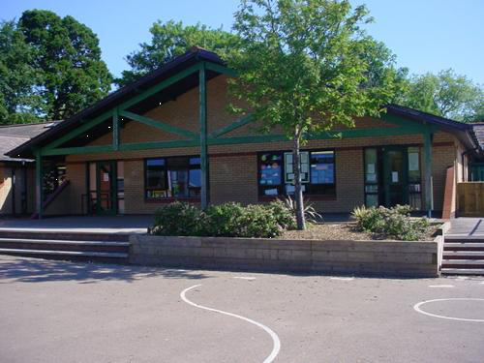

**Expressive Arts**

Study paintings of Rivers.

Create river paintings using a variety of media.

Create a topic display demonstrating the main features of a river.

Explore poetry and songs featuring rivers.

Explore Monet’s paintings to understand shape and form of rivers.

Music: BBC Radio for Schools –Perform songs from *Treasure Island* and *the Tempest*

**Health and Wellbeing**

Sports day

Healthy Living Week.

Learn and participate in team sports.

Express opinions in a debate about water pollution.

Flow

Llifo

Blwyddyn 3 a 4

**Humanities**

Use the eight points of a compass to describe locations or geographical features.

Identify the four stages of water cycle

Research physical features of rivers and how they are formed.

Research and compare rivers of Wales and the world.

**Science and Technology**

Compare water samples from different rivers.

Investigate aquatic and non-aquatic plants.

Investigate how different soils hold on to moisture.

Build own ‘mountains’ that show how water flow.

**Homework**

Visit a river and test the flow by playing Pooh sticks.

Visit a gallery and look at river paintings

Find out about how to save water around the home- make a Top Tips poster.

Grow something edible using soil – cress, broad beans or lettuce perhaps!

**Cymraeg:** Write aweekend diary in Welsh

**Language, Literacy and Communication**

Read and write stories from Wales and around the world

Read and write stories with a historical setting

Write a film trailer script.

Continue with reading groups and spelling

**Cymraeg**

Read and understand a Welsh book

Write a book review in Welsh.

Read a Welsh poem aloud.

Write, read and evaluate each other’s poems.

Understand and retell a legend.

**Maths and Numeracy**

Use a fraction wall to illustrate a variety of connections.

Use appropriate mental maths to add and subtract money.

Explore shape, symmetry and reflection

Collect data for tables, pictograms and graphs

Consolidate numeracy skills