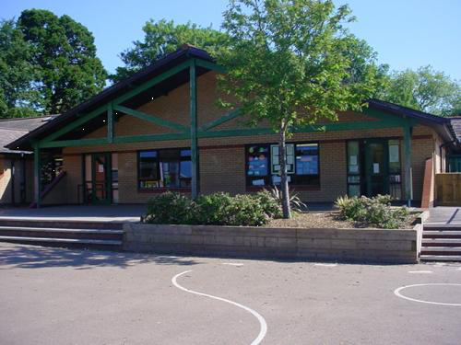

**Numeracy**

Using money to pay for items in relation to multiples of 10p, calculating change.

Multiplying a single digit by 20

Recall x 2 x3 x4 x5 x10 times table and visit / continue to practise x9

Year 3 Big Maths

Recall knowledge of number facts within 20 to add/subtract multiples of 100

**Innovate – Let’s get creative!**

Opportunities to participate in a mock volcanic eruption.

Locate using maps.

Organise a town evacuation. Explore types of suitable shelter. List supplies and create an action plan to assist in the mock emergency. Present your work.

**Tremors YEAR 3**

**PE**

Pupils will develop and practise the necessary skills required for this year’s sports day taking a multi-skills approach. *Precision Passing, Jumping Jade, Spots in Space, Patterns and Pathways* and *Pebble Plop*.

Following Sports Day, children can develop own versions of these games.

**Welsh**

Write a book review. Discuss holidays and school trips and write simple recount. Read, write and evaluate simple poems. Retell a legend. Discuss going to a holiday club.

Evaluate Year 3 progress in Welsh.

**Science Investigations**

How are rocks formed?

Explore earthquake strength.

What is in the soil?

**RE/SEAL**

RE – Continue to study Judaism.

SEAL – exploring relationships.

**Homework Opportunities**

Create a volcano model with baking soda and vinegar. Bring in photographs!

<http://www.sciencekids.co.nz/experiments/vinegarvolcano.html>

Draw and label a volcanic diagram.

Produce a presentation about a famous volcanic eruption.

Research the Richter Scale.

Write a diary about an earthquake/ tsunami / volcano eruption survival.

Design an earthquake-proof house.

Create a project dictionary that explains key vocabulary in your own words.

**Express**

Create volcanic rocks using a range of media.

Create a digital presentation to show learning using comic strip.

Perform Pompeii compositions to an audience.

**Develop**

Discover and explore layers of the Earth. Learn about different rock types. Investigate properties

Locate volcanoes on a world map / globe.

Find out what causes a volcano to erupt.

Develop a volcanic soundscape.

Build models of volcanoes.

Make sketches and clay figures from Pompeii.

Investigate cause of Tsunamis and Earthquakes.

**Engage**

Survey the local area to assess how different rock is used. Explore different rocks and crystals using photography and digital images. Study the work of Andy Goldsworthy to create own images

**Literacy**

*Fiction*: Folktales - *The Enchantress of the Sands* and writing our own folk tales

*Non- Fiction*: Biographies and autobiographies

*Grammar:* adverbs, adverbials, dialogue, spellings