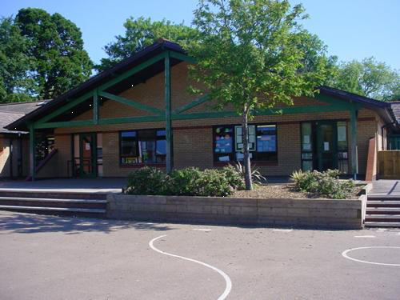

**Develop**

* Keep brine shrimp in classroom – study and observe.
* Research sea food chains -.
* Make notes on Blue Planet – report writing.
* Find out about famous voyages and voyagers.
* Create a debate on environmental issues eg. Tourism.

**Literacy**

* **Stories from another culture**

Powerful verbs, descriptive language, similes, metaphors, past tense, direct speech, nouns, pronouns.

* **Persuasive Writing**

Attention grabbing language, persuasive techniques, emotive language, persuasive language and phrases.

**RE/SEAL**

* Whose World? – Christianity and Buddhism
* Changes

**PE**

* Fielding and striking – cricket, rounders.
* Athletics – running, throwing, relay, jumping.

**Express**

* Create own sea creature ‘monster from the deep’.
* Sea scape paintings and drawings.
* Research and read about whales.

**Welsh**

Read Ych a Fi poem and write an Ych a Fi poem

Write a description of our trip to Bristol Sea Life Centre.

Create a tourist information poster to advertise Monmouth.

**Create and perform a new rap /**

**Learn and sing the Welsh folksong Sosban Fach**

**Science Investigations**

* How does pollution affect habitats?
* Where does water go?
* Are all sea creatures the same?

**Numeracy**

**Mathematical Development**

**Count** in 6s. Count in 25s, 50s and 250s (link to work with scales) Count forwards and backwards from any 3-digit number focusing on ‘tricky bridges’

Find 1/10 of whole numbers by dividing by 10

**Written methods** for addition and subtraction

**Compare and estimate** with numbers up to

Consolidate complements of 100, £10 and 1Identify numbers that are multiples of 50 and 100.

**Recognise connections** between fractions.

**Division,** written methods,

**Fractions** : addition and subtraction

**data** from charts, timetables, graphs

**weights and measures, time ,**

**Engage**

* Visit to Bristol Aquarium.
* Using keys to sort sea creatures.
* Watch documentary of deep sea eg. Blue planet.
* Poetry – James Reeves The Sea, personification
* Locate worlds seas and oceans.
* Make 3D model of the seas layers.

**Innovate – Let’s get creative!**

* Create a biography on sea creature observed.
* Create artwork depicting sea creatures.
* Take digital images of sea creatures – create a class book.

**BLUE ABYSS**

**YEAR FOUR**

**Homework**

1. Find facts about sharks or your favourite sea creature.
2. Create a picture dictionary of sea creatures and plants.
3. Make a tourist leaflet for a place such as ‘The Great Barrier Reef’.
4. Create Top Trumps on sea creatures – use lots of numbers.
5. Write a poem or song about the sea.