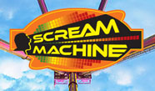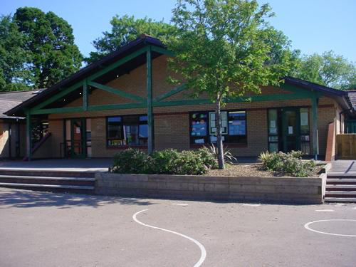

**Homework**

1.Research the history of fairground rides and create a powerpoint presentation or booklet including information, timelines, pictures and facts.

2.Make a flipbook to animate a rollercoaster ride that includes a loop the loop!

3.Research on line to find information about roller coasters from around the world. Which is the oldest, longest, scariest? Can you show your data in a table and graph?

4.Make a loop the loop using a flexible track. Change the track until a marble or car can successfully make it round the loop. Challenge family members to get the car / marble to land in a pot by changing the trajectory. Keep a tally of success rate.

5.Become a pendulum on the swings at the park. Swing as high as possible and time how long it takes you to stop. Time friends and family and look for patterns. Do heavier people slow down more quickly?

6.Keep a diary for a week in Welsh.

**Science and Technology**

-Finding out about forces.

-Gravity / pendulums/ gears, levers & pulleys.

-Investigate rollercoaster design.

-Design their own fairground ride, make a model of it and test it.

**Health and Wellbeing**

-Make fairground food for everyone to enjoy!

-Relationships

-Changes

Maths and Numeracy

Sequence of number – counting backwards and forwards in a variety of multiples within 10. Number systems –Reading, writing and ordering numbers to 100,000. Tables. Multiplying & dividing by 10 & 100. Rounding. Mental and written calculations – calculating fractional quantities. Adding, subtracting, multiplying and dividing 3 digit numbers and decimals.

Other areas – Multistep function machines. Congruent shapes, Translation, reflection and rotation of shapes. Mean, median mode and range. Volume. Basic algebra. Investigations.

***SCREAM MACHINE***

***YEAR FIVE***

**Language, Literacy and Communication**

**Language and Literacy -**

-Stories from another culture

-Non chronological reports

-Playscripts

-Discussion texts

**Topic**

-Write a poem using videos from the -Legoland trip to stimulate writing.

-Create a brochure for your theme park.

**Welsh**

-Rap Ailgylchu

-Compost Arbennig

-Dyddiadur

-Dewch i Gymru

**Expressive Arts**

- Create a poster to advertise their new ride.

- Photo edit an image to give roller coaster ride portrait.

- Design a theme park sign.

**Humanities**

- Compare web sites of the UK’s most popular theme parks & find them on a map.

- Calculate journey times and costs for a family day out.

- Study publicity, posters and maps of theme parks.

- Research types of rides and their locations.