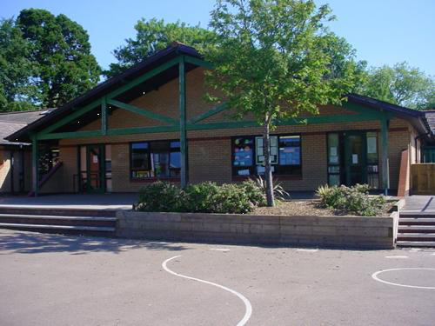

**Health and Wellbeing**

Creative gymnastics.

Take part in different sporting challenges, measure achievement.

Attack and defense games

Say No to Bullying

Going for Goals

**Homework**

*Find out about one of the following tropical soil creatures and create a fact file & / or make a model of it: Velvet worms / Tractor millipedes / Termite /Dung beetle.

*Has our Earth always looked the way it does now? Produce a time-line or presentation showing the formation of our planet.

*Write a book review on your favourite book. Persuade someone to read it! Add an eye catching cover.

*Make a picture of the Earth or Solar System using natural materials in your garden / park. Take a picture of it and upload it to Seesaw.

*Create an expressive dance entitled Earth. Share on Seesaw.

**Welsh**

Barti Ddu (transition)

Describing others (third person).

Family (y teulu)

Talking about myself (first person)

Food and prices

Days of the Week and Time

Diary Entries

Clothes

**Languages, Literacy and Communication**

Dilemma story.

Persuasive writing.

Story in a narrative verse.

Explanation texts.

Continue with spellings and reading.

Handwriting, working towards pen licenses.

Learn and recite extracts from narrative poetry

Write persuasive letters to the council and local paper on environmental themes

Write an explanation of how to reduce humans impact on planet Earth

Maths and Numeracy

Place value and partitioning

Addition and subtraction strategies

Multiply and divide amounts by 10, 100.

Derive complements of 1000 for multiples of 50 and 100 – number line.

Multiplication and Division facts

Fractions of shape and number

Measuring length, time and capacity

Properties of 2D and 3D shapes

Presentation and interpretation of data - bar charts, pictograms and tables

**Expressive Arts**

Earth song painting.

Art week projects.

Make percussion instruments from recycled materials. Compose and perform.

Futuristic artwork / footprints.

***Earth.***

***Year 3/4.***

**Science and Technology**

Why we get days, months & years.

Finding out about soil types.

What lives in our soils?

Drawing like Darwin.

The green house effect.

Recycling. Saving our planet Earth.

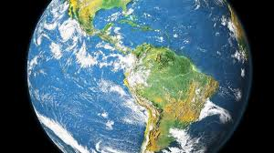

**Humanities**

Ancient and natural wonders of the world – locate and research. Present findings.

Landscape – volcanoes, earthquakes and rivers.

Creation stories, Mother Earth and Bing Bang

Seasonal Celebrations around the world

Creating fact files on soil dwelling animals/insects

Plastic free future