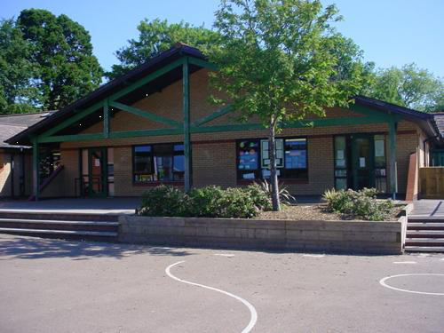

Gods and Mortals

Duwiau a bodau Dynol

Blwyddyn 3 a 4

**Science and Technology**

Create labyrinths and use positional language to exit the mazes.

Why did Icarus fall from the sky?

What is sand?

What is soil?

Using presentation packages

**Maths and Numeracy**

Place value and partitioning

Addition and subtraction strategies

Multiplication and Division facts

Fractions of shape and number

Measuring length, time and capacity

Properties of 2D and 3D shapes

Presentation and interpretation of data - bar charts, pictograms and tables

**Health and Wellbeing**

Practise athletic activities and measure achievements to track improvements.

Hockey skills

Say No to Bullying

Going for Goals

**Homework**

Taste traditional Greek foods and write a food review.

Plan a family holiday to a Greek island (as if money is no object!).

Spot buildings influenced by Greek architecture in Monmouth. Photograph pediments and columns.

Practise using the letters of the Greek alphabet. Write your full name and spell it out using the names of Greek letters.

Design your own mythical creature. Which animal’s body parts would you include and why.

Cymraeg: Write a diary entry in Welsh`

**Cymraeg**

Create a brochure about Monmouth

Read the book, Miriam

Food and prices

Days of the Week and Time

Diary Entries

Clothes

**Language, Literacy and Communication**

Composing poetry

Journalistic Reports

Narrative Verse

Diary writing

Instructions

Debate: Whether or not to allow the wooden horse into Troy

Letter Writing

Speech writing and delivering

**Expressive Arts**

Music: BBC Radio for Schools *Heroes of Troy*

Study Greek pottery colour, decoration and shapes then create own pots.

Build and decorate papier mache Minotaurs’ heads

Model a crown fit for a new deity

**Humanities**

Create a sketch map of Ancient Greece with major islands, mountains and seas.

Order events of importance in Ancient Greek history on a timeline.

Study the story of the Trojan Wars

Label Greek soldiers’ equipment and weapons and drill as hoplites

Legend of Theseus and the Minotaur

The story of Pandora’s box