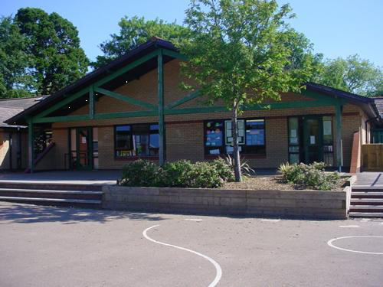

**Health and Wellbeing**

* Gymnastics.
* Ball and stick games (hockey).
* Healthy eating.
* Balanced diet.

**Homework**

1. Write a weekly food diary (this could be done in Welsh).
2. Design an exciting sandwich and make it (write down the recipe).
3. Write a shopping list for your family for a week and calculate the cost.
4. Write a story that begins “You’re not going to eat me are you” said the….
5. Make an alphabetic list of foods from A to Z if possible (perhaps in Welsh).
6. Try a food you have never tried before and tell your teacher all about it.

Maths and Numeracy

Decimal place value

Decimal and fraction equivalence

Money

Adding and subtracting decimals

Mental Strategies for multiplying and dividing TU

Inverse operations

2,3,4,5,6 and 10 times tables

Negative numbers

Time

Charts and bar graphs

**Across the curriculum**

Party planning, shopping costs

Caluculating VAT

Menus

Surveying foods

**Expressive Arts**

* Food Pop Art
* Still life drawings

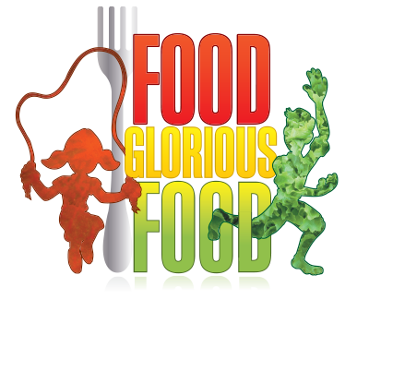

**Humanities**

* History of food (food through the ages).
* Food from around the world (origins).
* Local foods.
* Famine/world issues.
* World religions.
* Food in religion.

**Languages, Literacy and Communication**

* Poetry (Unit 4) – Prefixes, creative language.
* Science Fiction (Unit 3) – Using a and an, conjunctions, adverbs, adverbials.
* Instructional texts (unit 2)
* Explanation texts (Unit 4)

**Across the curriculum**

* Advertisements, persuasive writing
* Recipes
* Menus

**Welsh**

* Llyfr Lloffion
* Amser
* Dydd sadwrn
* Diwrnod y llfyr
* Dau gi bach
* Anifeiliaid Anwes

**Science and Technology**

* Food technology.
* Advertising and packaging.
* Food chains.
* Digestive systems.
* Balanced diet.