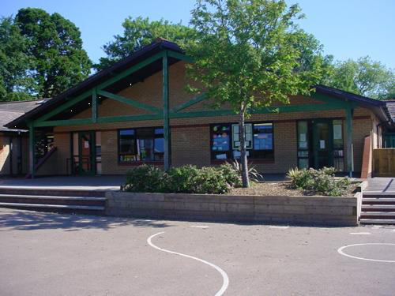

**Welsh** (Antur Anhygoel Glas)

* Yn yr ardd
* Yr tren bach
* Plannu bylbiau
* Y pod antur cymraeg
* blanned I blaned
* Noson tan gwyltt
* Yn y caffi
* Edrychwch ar y golau

**Humanities**

* Extreme weather
* Extreme locations
* Extreme beliefs
* Journeys/expeditions eg. Poles, Mountain climbs

**Health and Wellbeing**

* Extreme sports
* Surviving extremes
* Sporting records (push yourself to your extreme)
* Parkour

**Homework**

1. Extreme Reading - Read a book in an extreme, unusual or creative location (take a picture and post it on seesaw).
2. Extreme Cooking – make a familiar recipe but increase its size eg. Giant cookie, jaffa cake etc…
3. Extreme Sports – try a new sport that challenges your abilities.
4. Extreme art–create extreme or giant art. See link:

https://www.youtube.com/results?search_query=art+attack+big+art

1. Create a survival guide for surviving an extreme location or event.
2. Extreme locations – find out the distance to extreme location. Let us know the distances using unusual measurements eg. How many mars bars to the moon?

Maths and Numeracy

* Counting forwards an backwards 4 digit number and decimals
* Place value up to 100,000
* Ordering decimals
* Halving and doubling decimals
* Proportions
* Converting decimals/fractions
* Derive percentages (of amounts)
* Addition and subtraction (3 and 4 digit numbers)
* Multiplying HTU by U and TU by TU
* Problem solving (estimation/inverse)
* Costs/money/profit/loss
* Shape/space/data

**Expressive Arts**

* Graffiti, extreme colours
* Create music soundtracks to extreme events eg. Storms
* Voice recorder art to extreme events



***Year 5/6 Autumn 2020***

**Languages, Literacy and Communication**

* Poetry
* Stories from other cultures
* Autobiography/Biography
* Persuasive

**Literacy across the curriculum**

* Weather reports
* TV reports
* Diary/journal extracts

**Science and Technology**

* Extreme foods and flavours
* Extreme wildlife
* Space and beyond
* Megastructures