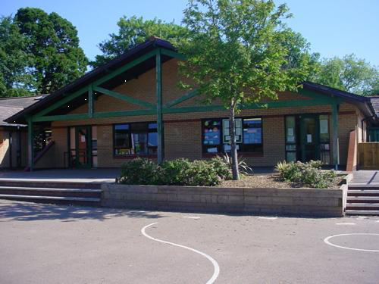

**Homework**

*What do you recycle at home? Can you improve the amount of recycling done? Make a presentation / booklet to share with your class.

*Create a poem about an animal you feel is endangered by ‘pollution’.

*Create a game with rules that could be played to encourage throwing and catching.

Collect data on amount recycled each week or each day for a week. Present data as a graph or pie chart.

Find out the source of the foods you eat at home. What country were they produced in, how far have they travelled?

**Health and Wellbeing**

**Throwing and Catching Games:** Pupils to learn key skills and compete in Netball/handball games etc

**Dodgeball/Benchball:** Pupils to compete in small teams against each other. Encourage agility, teamwork and accuracy.

**Science and Technology**

Fire triangle and combustion.

The Greenhouse effect & global warming.

Electricity production. The Water Cycle.

Microbes and fingerprints.

Eco designs for the future.

Maths and Numeracy

Calculate food miles for a healthy lunch.

Gather data on waste found in various sites around Monmouth (sort, weigh etc.). Present data in tables & graphs, analyse.

Calculate the carbon generated by different journeys / forms of transport.

Compare data on weather around the world, work out mean, median, mode. Study patterns over time and look for trends.

Calculate % increase in costs / time taken of more environmentally friendly solutions

***Footprint***

***Year 5 / 6.***

**Languages, Literacy and Communication**

**Fiction**

Create free verse poems about our town: Monmouth. Create poems about the journey of water (molecule) and a sea creature linking to the pollution in our waters.

**Non-Fiction**

Write a piece of persuasive text from the scenario of a sea creature wishing to stop polluting in the seas/oceans. Also, write an election speech. Children will create their own manifesto for what they believe needs to change and convince an audience.

**Welsh**

Writing a report in past tense about the Christmas Holidays.

Looking at the lives of evacuees from World War 2

**Expressive Arts**

Use recycled materials to create new products.

Explore the work of established artists who use recycled materials in their artwork and create our own version of this art.

**Humanities**

Investigating connections we have with other countries.

Investigating food miles and how we can eat seasonally and locally.

Working out our ecological footprint and looking at ways to improve this.

Assessing the importance of famous figures in tackling climate change.

Carry out an investigation into littering/recycling in the local area.