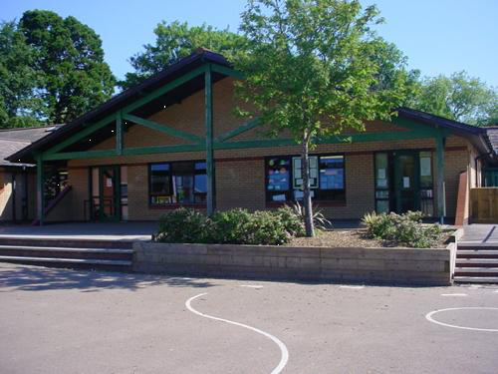

**Homework**

\***Write a review of a computer game.**

**\*Design a costume & travel kit for an Alchemist. Draw it, describe and explain your choices of material and colour, make it?**

**\*Make your own gemstone. Wax, jelly, plaster! You could include an instruction sheet so your friends can try it!**

**\*Design and make an Alchemists Banquet. Describe any changes of state, reversible/not?**

**\*Write a diary extract of your weekend in Welsh.**

**Health and Wellbeing**

**New beginnings.** **Celebration of differences and similarities. Exploring belonging to a group. Learning conditions. Starting new things.**

**Invasions games.**

**Skills based team games.**

**Gymnastics.**

**Language, Literacy and Communication**

**Myths and dilemma stories/Recounts**

**Relative clauses/Synonyms**

**Explain and discuss understanding of information read in a formal way, justifying viewpoints.**

**Use vocabulary for effect, using dictionaries and thesauri to extend breadth.**

**Note making including topic-specific vocabulary.**

**Welsh**

**Blaned i blaned**

**Noson Tan Gwyllt**

**Yn y Caffi**

**Edrychwch ar y golau**

**Expressive Arts**

**Explain how moods & effects are created in music.**

**Create simple rhythmic patterns & perform from simple notation.**

**Read, recite & remember Prospero’s soliloquy.**

**Write and perform their own soliloquy, using language for effect.**

**Create a soundtrack to go with a video game based on Alchemy Island.**

**Pitch ideas to the game company’s board of directors.**

**Discuss techniques used by song writers when composing lyrics. Then compose their own lyrics using the different parts of their adventure on Alchemy Island.**

**ALCHEMY ISLAND**

**YEAR FIVE**

**Humanities**

**Recognise and describe physical & human features of places.**

**Putting faith into practice / Why care for others?**

**Focus on Christianity & Sikhism.**

**Use grid references to locate features on a map.**

Maths and Numeracy

Working with decimals and fractions, adding and subtracting.

Different strategies for subtraction.

Different multiplication strategies.

Calculating with money.

Measure and record temperature, negative numbers.

Acute and obtuse angles

Sequences of numbers

Properties of triangles

Coordinates: reading and plotting.

**Science and Technology**

**Investigating materials and their properties.**

**Separating mixtures – cleaning water samples.**

**Comparing reversible and irreversible changes.**

**Collect data and present using tables and graphs.**

**Making simple circuits.**

**Use a range of software to create portals that could be used to reach Alchemy Island.**

**Build models, incorporating switches.**

**Produce algorithms & make digital images of themselves.**

**Design & make a board game based on Alchemy Island.**