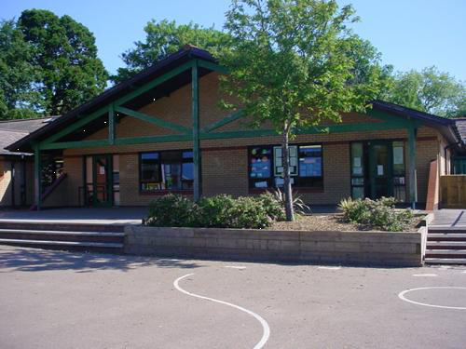

**Homework**

1. Create a brochure to visit the Arctic

2. How would a domestic animal adapt to survive in the Arctic?

3. Create a Polar Collage.

4. Make a model of your favourite Arctic animal

5. Design a pair of snow boots for an Arctic explorer. What materials would you use? What features could they have?

6. Write a Welsh diary extract?

**Welsh**

Poetry about Fireworks – read the poem aloud, perform the poem, write a new poem. Persuade a friend to join an activity using a range of new language patterns.

**Language, Literacy and Communication**

Language and Literacy: Unit 2

Fiction: (Poetry: The Power of Imagery)

‘Rabbit in Mixer Survives’

Free Verse Poetry: Arctic Animal

Free Verse Poetry: Northern Lights

Non-Fiction: (Argument)

‘Should humans really rule the Earth?’

‘Animals rule…but which one?’

**Expressive Arts**

Write music to accompany the Northern Lights.

Explore Inuit cave paintings and recreate using printing techniques.

Frozen artwork

Christmas Crafts

**Frozen Kingdom**

**YEAR 6**

**Maths and Numeracy**

Measurement of temperature, negative numbers

**TAPAS:** Identify common multiples of two numbers, factors of two numbers and square numbers. Be able to find the area and perimeter of compound shapes. Understand angles and how to draw accurately. Estimate angles and draw reflex angles. Measure and record temperatures involving positive and negative readings. Make comparisons of data from around the world and calculate differences.

**Humanities**

Read a range of factual accounts of the sinking of the Titanic and timeline the events. Order the events of this disaster and debate the person responsible. Devise a rescue plan after a holiday cruiser has hit densely packed ice.

**Health and Wellbeing**

PE – indoor – dance/yoga.

PE – outdoor – training methods

SEAL – changes to our bodies, looking after ourselves.

Growth Mindset – changing the way we think about ourselves and the things we can do.

**Science and Technology**

Look at a range of wonderful icebergs and ice formations – write an information leaflet about icebergs.

Explore food chains and food webs of animals in cold conditions.

Investigate animal adaptations and how these have helped Arctic/Antarctic animals to survive cold temperatures.