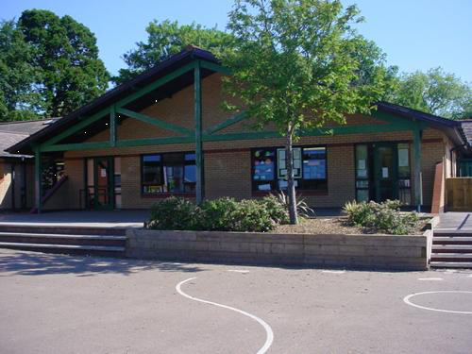

[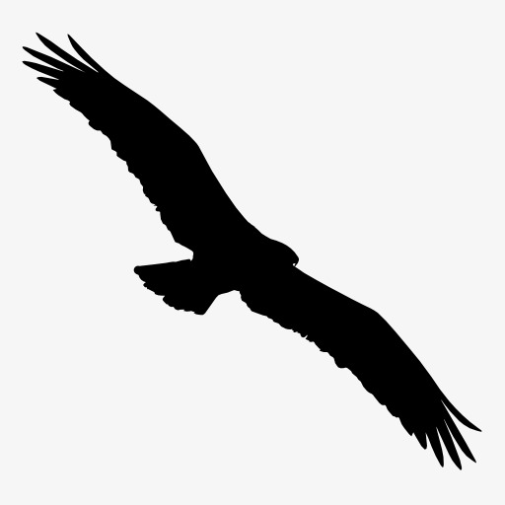](https://www.google.co.uk/url?sa=i&rct=j&q=&esrc=s&source=images&cd=&cad=rja&uact=8&ved=2ahUKEwig7KKe2Z7dAhWSLVAKHf0dDQEQjRx6BAgBEAU&url=https://pngtree.com/freepng/eagle-silhouette_947080.html&psig=AOvVaw3RfJThbdpYbStr9PWVxAHD&ust=1536059347429808) **Predator**

**Blwyddyn 3 a 4**

**Humanities**

Research habitat & locations of peregrine falcon. Possible visit to Birds of Prey Centre.

Research aquatic predators, where are crocodiles & alligators found in the wild?

Learn about predatory birds, insects, reptiles, amphibians & other animals

Compare features of predators – look at images of fossils of predatory dinosaurs.

To appreciate that people can worship in a variety of ways and places

Going for Goals & Good to be Me

**Expressive Arts**

Fabric collage of some predators studied

Study human parasites (Yuk!) and the cuckoo (parasitic bird)

Study predatory birds . sketch birds in flight.

Find a picture of favourite predator, compare with picture of a friend. Compare features.

Name new predator, create fact file – habitat, prey, food chain, features.

**Maths and Numeracy**

Multiply and divide amounts by 10, 100.

Derive complements of 1000 for multiples of 50 and 100 – number line.

Continue to learn times tables

Derive division facts and fractional quantities from multiplication facts

Present data - bar charts, pictograms, tables

**Language, Literacy and Communication**

Poetry – water cycle poem

Shape / sound poetry

Explanation of water cycle, life cycles

Use dictionaries & thesauri to find the meaning of unknown words

Leaflet on terrestrial predator

Haiku poem on bird of prey

Consider features of good speeches.

Write speech about own apex predator, deliver finished speeches in assembly.

Complete leaflet of favourite predator

Complete glossary of terms

**Welsh**

Describing others (third person).

Family (y teulu)

Talking about myself (first person)

**Health and Wellbeing**

Creative gymnastics.

Take part in different sporting challenges, measure achievement.

Play prey / predators attack & defence games

**Science and Technology**

How do fossils form?

What do owls eat?

What are our joints for?

Study carnivorous & predatory plants, draw simple diagrams of plants circulatory system

Study skeleton & muscles of humans / animals

Study food chains, predators & prey

Use ICT to produce food chain flow diagram

Create new predator by merging digital images.

**Homework**

Research predators, write unusual facts to put on class display. Find the most amazing predator names

Make a predator glossary of key terms.

Write a short story from the point of view of a predator or its prey

Write a set of instructions for how to care for an unusual predator

Make predator fact files with statistics

Ultimate predator models / drawings