[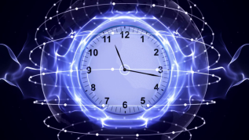](https://www.google.co.uk/url?sa=i&rct=j&q=&esrc=s&source=imgres&cd=&cad=rja&uact=8&ved=2ahUKEwit6qrPm5LdAhVHyRoKHagPCCwQjRx6BAgBEAU&url=https://www.videoblocks.com/video/clock-time-travel-in-fibers-ring-rendering-animation-background-loop-4k-bffp7tdheixguyg58&psig=AOvVaw3jxkpTjx5OKdEI-1s7OBok&ust=1535630519815570)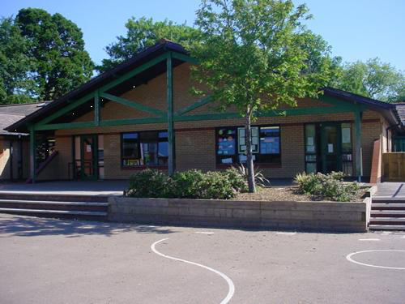

**Welsh**

- Yn yr ardd

- Y tren bach

-Plannu bylbiau

-Pod antur cynraeg

-O blaned i blaned

-Noson tan gwyllt

-Yn y caffi

-Edrychwch ar y golau

**Expressive Arts**

-Create a character study by looking at photographs and collecting a range of interesting adjectives to describe them.

-Design and make a clock.

-Make a digital montage of themselves in the style of Andy Warhol’s ‘Marilyn Monroe’ prints. Use mixed media to create a collage that reflects their hope and dreams for the future.

-Look at quotes about time and create a collaborative poem including similes and metaphors.

**Language, Literacy and Communication**

**Language and Literacy –**

-traditional tales

-instructions

-dilemma stories

-recounts

**Topic**

-stories through time

-instructions – how to build a time machine

-diaries from the past

**Humanities**

-Talk to people in the community about local changes they have seen over the years.

-Solve a range of time related problems.

-Investigate how an aspect of everyday life has changed over the past 200 years and display as a chronological time line.

-Research the current UK population.

**RE**

-Putting faith into practice / Why care for others?

-Focus on Christianity & Sikhism.

***SCREAM MACHINE***

***YEAR FIVE***

Maths and Numeracy

Sequence of number – counting backwards

and forwards in hundreds, tens and tenths.

Place Value - partitioning, rounding, 10/100 times bigger smaller.

Halving. Tables. Decimals.

Mental and written calculations – Simple proportions. Fractions. Percentages. Doubling diamond. Addition techniques. Subtraction. Multiplication methods.

**Health and Wellbeing**

-Skills based team games and Dance.

-Invasion games

-Dance

**SEAL**

-New beginnings. Celebration of differences and similarities. Exploring belonging to a group. Learning conditions. Starting new things.

**Homework**

1. Talk to members of your family to find out changes that have occurred since they were 10. Is the World a better place now?

2. Create a time line for your family showing important events eg births, marriages, house moves. This could include photos.

3. If you could time travel to any time and any place in the World, where would you go? Make a scrap book of your adventure showing what you would do while you were there.

4. Complete a survey to find out which aspect of technology would be missed most.

5. Draw and label a design for a product of the future.

6.Keep a diary for a week in Welsh.

Science and Technology

-Using personal photos from home build up a time line of their lives.

-Collect and analyse data on temperature through a day.