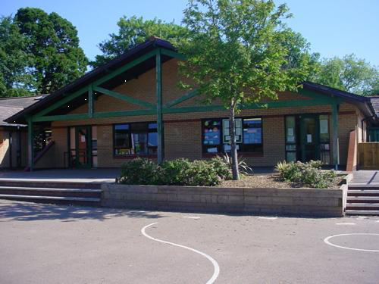

**Health and Wellbeing**

* Debate the use of identity cards or microchipping for children. Express opinions considering both sides of an argument.
* Hockey: Pupils will learn how to perform a lateral dribble and push pass.
* Rugby: Pupils will learn how to side step, pass the ball using pop, gut and lateral pass.

**ID**

**YEAR 6**

**Homework**

* Create a collage or montage that represents your personality. Use poster, magazines etc.
* Investigate similarities and differences in your family. Eg. Who can roll their tongue?
* Research your dream job and create a fact file.
* Create a fact file of world records of sporting events and consider whether everyone can compete in sports.
* Write about a friend or family member in Welsh – how much can you include?

**Humanities**

* Compare and contrast areas of the UK and the wider world.
* Find out about influential figures who brought back social reform. Dr. Barnardo, William Wilberforce etc.

**Language, Literacy and Communication**

Language and Literacy: **Unit 1**

Fiction: retelling narrative (legends)

Robin Hood and the Golden Arrow

Non-Fiction: Journalistic writing

The Sherwood Bugle, Good Day, TV interview

Extended Writing

* Non-chronological report about solving a crime
* Retell the story of the Tiny Crusader
* Write a report about a country

**Welsh**

* Personal profile – baseline assessment
* Ynys y Barri – recount a trip to Barry Island. Learn the story map and create their own based on a trip.

**Expressive Arts**

* Splice a portrait photograph of themselves alongside a sibling, parent or grandparent.
* Design and create a bag or t-shirt using inspirational images and techniques including stitching, bonding and applique methods.

**Maths and Numeracy**

Decimal place value (Rounding)

Halving and doubling

Multiplication –

If I know… doubling 2x7 then 4x7/8x7.

Fractions

Add and subtract 3 digit multiples.

Represent data in the form of graphs and charts.

Use Median, Mean, Mode and Range.

Gather data on features and build a spreadsheet to compare

**Science and Technology**

* Devise a classification key based on physical features
* Create a class survey using online software and collate data on a national level to compare and contrast responses.
* Use a number of scenarios to help them spot signs that electronic communications may be from an imposter.