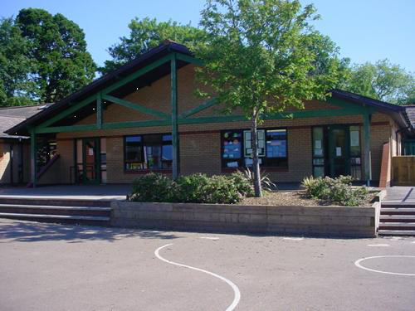

**Welsh**

* Llyfr lloffion
* Goedwig
* Treath
* Email
* siopa
* nadolig

**Expressive Arts**

* Beat boxing
* Create a rap.
* Design an album cover.
* Musical theatre/animation.
* Producing.

**Homework**

* Listen to a variety of genres of music, create your own playlist.
* Write a fan letter to a musical hero explaining why they like their music.
* Compose a piece of music and perform to an audience.
* Create a timeline of Welsh musical events.
* Cost a trip to see a musical concerts?
* Find different songs for different emotions.

**Science and Technology**

* Can we block sound?
* How can we change sound?
* How far can sound travel?
* Designing and making musical instruments.

**Health and Wellbeing**

* Just Dance
* Mental Health Awareness
* Rugby/Netball skills

Maths and Numeracy

Counting forwards and backwards

Place value to 3 or 4 digits

Doubling and halving

Adding and subtracting 2 and 3 digit numbers

Multiples

Estimation and rounding.

Money.

Mental recall within 20 and 100.

Multiplying single digit numbers.

Checking answers using inverse.

Order and compare up to £100.

***Playlist***

***Year 3/4***

**Languages, Literacy and Communication**

A series of unfortunate incidents – Lemony Snicket

* Mystery stories (Unit 5) – Adverbs, word families, sentences, tense.
* Playscripts (Unit 2) – Adverbs of time.

Music and Musical Instruments

* Biographies (unit 6)
* Information texts (Unit 1)

**Humanities**

* History of music in Monmouthshire.
* Visit to Rockfield Studios.