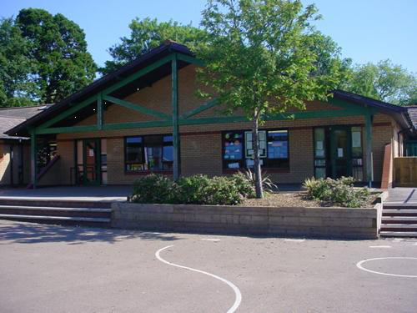

**Science and Technology**

Phases of the moon.

Researching planets & presenting their findings.

Designing rockets and space landers. Investigating craters.

**Health and Wellbeing**

Gymnastics – exploring shape, travelling and small routines.

Hockey – passing, dribbling, rules and game play

**Homework**

* Research and write a profile on a famous astronaut.
* Collect data and prepare graphs about the transport on your street/in your local area
* Listen to the Planet Suite by Holst and create artwork that comes to mind
* Go on a visit or find out about transportation in the local area
* Design your own planet, making a model/booklet with the important information about your planet.
* Can you walk/cycle for a week instead of using the car?

Maths and Numeracy

* Mental and written calculations involving whole numbers.
* Ordering numbers
* Place value, halving and doubling
* Fractions and decimals of amounts, and fraction, decimals and percentages equivalents.
* Multiplying 2 and 3 digit numbers
* Reasoning activities
* Money related Enterprise week activities

***ZOOM***

***Year 5/6***

**Languages, Literacy and Communication**

Fiction:

Stories of different genres including historical and science-fiction.

Famous authors – writing in the style of famous authors including Michael Morpurgo, comparing and contrasting with other authors.

Non-fiction:

Autobiography and biography.

Journalistic writing: writing travel brochures and research into countries around the world and newspaper articles.

**Welsh**

Ynys y Barri – past tense, describing events, creating story maps, writing a recount.

Poetry – reviews of poetry

**Expressive Arts**

Create a musical journey – thinking about the build up, and end of the journey using musical instruments.

Use sewing skills to attach sequins and beads to felt moon shapes.

Investigating and reacting to music related to space.

**Humanities**

The history of transport and the effect on South Wales.

The Space Race, steam travel and fuel.

School trip for a real life transport experience.

Pilgrimage and religious journeys