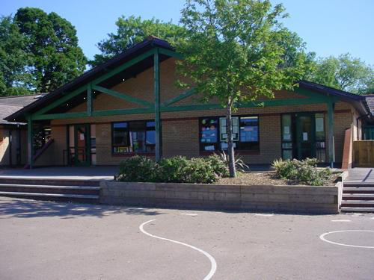

**Humanities**

* Who were the Celts? Research
* Compare now and then.
* Research ‘bog bodies’ and how iron age remains have been preserved.
* Research the druids.
* Research Celtic warrior fights.
* Discover what life was like for an iron age child.

**Science and Technology**

* Discover what is needed to start a fire in the wild, and keep it burning.
* Make a bread dough using an iron age recipe.
* Investigate water transportation in plants.
* Dissect a flower and understand its parts.
* Investigate seed dispersal.
* Investigate fungi. Are all mushrooms harmful?

**Cymraeg**

* Dewi Sant
* Welsh cakes
* Describing others
* Family

**Homework**

* Research Boudicca. Present your findings as a fact sheet, poster or any other way you like!
* Write a diary as a Celtic farmer.
* Find out about Celtic hoards and treasures found in Wales and further afield.
* Create a quiz about the Celts and test a family member.
* **Cymraeg:** Write a Welsh diary entry

**TRIBE!**

**Llwyth!**

**Blwyddyn 3 a 4**

**Health and Wellbeing**

* Create an iron age clan. Work co-operatively to solve problems.
* Choreograph sequences based on a Celtic warrior fight.
* Gymnastics.
* Attack and defence games.

**Language, Literacy and Communication**

* Follow a recipe to make Iron Age bread dough.
* Tell stories, just as the Celts did, around a fire.
* Read and explore a range of historical texts. Discover sources and compare bias.
* Create fact files and information booklets.
* Non-chronological report writing.
* National test preparation.

**Maths and Numeracy**

* Weights and measures.
* Coordinates and shape orientation
* Continuation of general number work, including multiplication tables.
* Capacity and volume.
* 2D and 3D shape properties.
* National test preparation.

**Expressive Arts**

* Create roundhouses.
* Participate in an archaeological dig.
* Create clay gifts for the druid gods.
* Design some new iron age costumes – host a fashion show!
* Create Celtic jewellery.