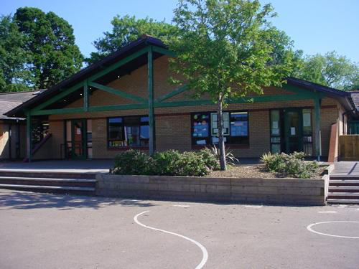

**Expressive Arts**

Dance from BBC Radio for Schools *Time to Move* **Alice in Wonderland**

Songs from BBC Radio for Schools Musical **Macbeth**

Dance (collective) portraying the potions scene from Romeo & Juliet or Macbeth

Design a fabulous potion bottle

Design potion bottle and labels

Write a spell with percussion accompaniment

**Potions **

**Blwyddyn 3 a 4**

**Maths and Numeracy**

Measure temperature in ‘C

Draw and interpret graphs

Capacity – convert between different units of measure

Mathematical word problems linked to the story **Alice in Wonderland**

**Language, Literacy and Communication**

Romeo and Juliet: look at the play script and alternative endings

Use the story of Alice in Wonderland to introduce the idea of potions

Write recipes for potions

Write spells

Design labels and advertising posters for our potions

Witches scene from Macbeth

**Welsh**

**Cantre’r Gwaelod** – a Welsh legend

**Ych a fi!** Our likes and dislikes

What can we do in **Aberystwyth**?

**Humanities**

Use of potions in history

Look at medicines from the past

Research famous wizards and witches

Use of medicines in the past

Tribal beliefs in witch doctors

**Health and Wellbeing**

Journeys with meaning

Sports and Healthy Eating Week

Good to be me.

Relationships

Striking and fielding (Rounders)

**Science and Technology**

How do smells get up your nose?

Is custard a liquid?

Are all liquids runny?

Investigate the property of bubbles. Investigate reactions of vinegar and bicarbonate. Investigate air and water in balloons at different temperatures.

**Homework**

Make a list of solids, liquids and gases found at home.

Calculate how many litres of water it will take to fill your bath.

Visit the library, search a story or play about potions then write a book review.

Make sketches of interesting bottles. Add details.

**Cymraeg:** Write a half-term holiday or weekend diary in Welsh