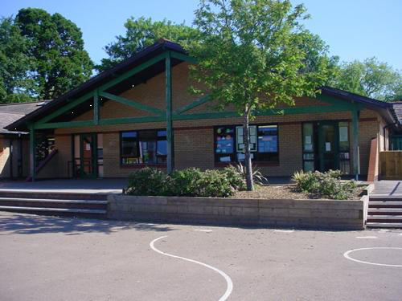

**Homework**

* Which part of Mexico would you like to live in and why?
* In Mexico, Spanish is the spoken language. Find and copy some phrases.
* Plan an imaginary trip to Mexico, look at holiday brochures.
* Design and build a Maya temple using junk materials.

**Humanities**

* Identify and locate places and environments using globes/atlas of Mexico
* Describe the daily life of a Mexican child
* Learn about the Maya civilisation
* Make similarities and differences between Mexico and the UK.

**Language, Literacy and Communication**

**Fiction: Micheal Morpurgo ‘’I believe in** Unicorns’’

Write a new episode for the story, exploring how Tomas would feel if separated from his parents

**Non-Fiction: Explanation Text**

Write a text explaining how to make a book a best-seller and how to engage readers.

**Welsh**

Dewch I Gymru

* Read a postcard and respond
* Create a brochure/leaflet about Wales

**Expressive Arts**

* Listen to ‘El Jarabe Tapatio’ and identify instruments they hear.
* Repeat the sounds using instruments
* Create stone carvings (glyphs) like the Maya Stelae
* Learn a Mexican dance

**Hola Mexico!**

**YEAR 6**

**Maths and Numeracy**

* Symmetry: Identify lines of symmetry for regular polygons
* Plan a trip to Mexico, thinking about budget and profit
* Find the volume of a cuboid
* Ordering of negative numbers
* Algebraic terms
* Probability
* Estimate the length of time of everyday activities and length of objects with accuracy
* Draw nets of cubes/cuboids

**Health and Wellbeing**

PE – Athletics, team games & Kabbadi

Discuss healthy foods and food groups

Pupils will work in teams and individually to compete in Athletic events.

**Science and Technology**

* Look a t how lights and shadows created in Mexico (Chichen Itza) during equinox.
* Follow recipes to create savoury Mexican dishes. (Guacamole/burritos)
* Explore Mexico using google Earth
* Use google maps to locate places of interest in Mexico