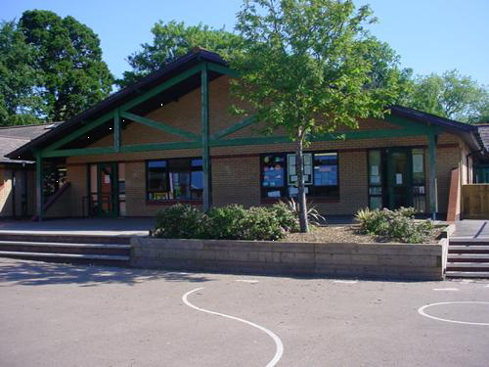
Literacy
RWI/L & L sessions: Daily phonics, guided reading and handwriting activities
Non-chronological reports: postcards, weather reports.
Weather poems
What will you find over the rainbow? Imaginative writing – Fantasy/ real?
Travel agents role play – booking forms, passports, travel reports, guides.
Seasonal stories and story writing

Develop
Focus on poetry, ‘Who Has Seen the Wind?’ by Christina Rossetti. Write poems – write rain poems outside on a rainy day, feeling different weathers.
Make kites, windmills, measuring the speed of wind.
ICT - Consequences of extreme weather research.
Write lists for a rainy day – things you can do on a rainy day.
Dance – weather routines.
Cloud gaze - looking at formations
Aerial images and birds-eye views
Sketching maps
Variety of balances with partner
Postcards from around the world

Numeracy
Recite numbers beyond 50/100, forwards, backwards
Partitioning teen numbers, partitioning 2 digit numbers,
Count and group in 2s, 5s and 10s
Combination of money up to 10p, up to £1
Count reliably up to 20 objects
Read and write numbers to 20
Graphs of weather
Measure rainfall and daily temperature
Add/subtract up to 10/add and subtract 11 from a given number
Express
Seasons – Focus on changing by tree artwork
Art related to the weather/designs on clear umbrellas/Sun-catchers/wind blowers
Innovate – Let’s get creative!
Stories and poems about balloons
Messages on balloons for their finder and release them on Monnow Bridge
Talk about what might happen – Hopes and Dreams

Splendid Skies – FP – Year 1 & 2
Homework
Visit the library and bring in a weather book.
Take Teddy home – on holidays, visits etc. Record adventures
Rainbow picture/artwork
Learn how to fly a kite – write instructions
Plant a flower and measure its growth

Science Investigations
Making a rain cloud with shaving foam, water and food colouring, Shadows – drawing around at different times of day, Light – rainbows. Materials – waterproofing, natural/man-made items
Engage
Memorable Experience: Nature treasure walk. Children collect treasures along the way using a stick covered in double sided tape, collecting items in order
Create memory box and take photos using iPads – record on Seesaw
Recount of the seasonal walk – Ordinal language/time connectives
QR codes with clues in different areas for the children to scan to search for treasures
Make a seasonal book
Record daily weather – clouds in particular, looking at shape, size and colour, temperature and rainfall
Focus on weather patterns and changes in weather all around the world
Research Global Warming and its effects
Identify weather in different countries. Identify on a world map – pack an appropriate suitcase for a holiday

Welsh
Hwyl Dan 7 – Pecyn Melyn, Glas, Gwyrdd.
PE/Music
Dance – weather routines
Partner work with balances, shape, direction, etc.
percussion music for the seasons
Diwali and new beginning dances
RE/SEAL
New Beginnings - good and bad choices, Harvest, Keeping safe, looking after our environment, recycling, Diwali

