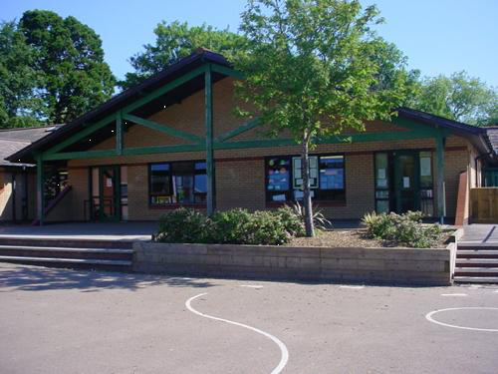

**Humanities**

Explore seasonal changes in our local area.   
  
Talking about our own families and learning about others.   
  
Exploring how birthdays are celebrated  
  
Cultural celebrations: Bonfire night, Remembrance, Halloween, Harvest, Diwali, Advent, Christmas.

**Health and Wellbeing**

Foundation Phase Profile Assessments – Personal and Social Skills & Physical Skills

Learn the routines and independent skills of our new Reception world.

Staying safe – handwashing, coughing etc.

Making friends and being a good friend

Create our own set of rules for our Class Charter. Discuss our School Pledge.

Learning about our faces, bodies, things that are the same and things that are different.

Cooking familiar foods.

Culturally relevant and topical resources in home corner to reflect the diversity of our world.   
Talk about what we are thankful for at Harvest time. Children in Need- learning about others who are not so fortunate.

Participate in PE sessions in the outdoor environment.

**Homework**

Introduce daily home reading and phonics learning  
Maths activities  
Researching/exploring the wonderful world around us  
Welsh - ______ ydw i. Writing and picture.

**Science and Technology**

Foundation Phase Profile Assessments – (use of mouse and touch screen)

How do animals behave in Autumn and Winter. Which animals live in our school and local environment?

How do trees and plants change at this time of year? Which plants can be found in our school and local environment?

Can you build familiar buildings from our local area?

**Maths and Numeracy**

Foundation Phase Profile Assessments

Counting with natural (seasonal) objects, measuring with sticks,

Autumn scavenger hunt (counting and size), sorting Autumn objects (data handling). Numbers in my world (my age, my birthday, my door number, how many in my house?)

Adopt a tree – observe the passage of time.

Daily Maths times to include:  
Recite numbers to 20 forwards and backwards. Read, write and order numbers to 10. Count reliably up to 10 objects. Explore stories of 4. Recognise regular dice patterns. Begin to understand and use vocabulary of addition/subtraction by adding/subtracting within 5. Combine two groups of objects within 5. Recognise and sort coins to 10p. Use 1pcoins to pay for items up to 5p. Recognise and name basic 2D shapes. Create a simple symmetrical picture. Sort and classify objects.

*Our Wonderful World*

*Reception*

*Autumn Term 2020*

**Welsh**

Learn how to answer the lunch register- ‘Ga i cinio/bocs bwyd/ tatws pob, os gwelwch yn dda’.

Recite our school prayer in Welsh.

Answer the question ‘Pwy wyt ti?’- _________ ydw i.

Answer the question ‘Sut mae tywydd heddiw?’- learning the weather in Welsh.  
Counting – Sawl un? Rhifwch gyda fi…  
colours – Pa liw?

**Languages, Literacy and Communication**

Foundation Phase Profile Assessments

Range of stories, including: Here We Are by Oliver Jeffers, Stanley’s Stick by John Hegley, The Gigantic Turnip by Aleksei Tolstoy, This Is Our House by Michael Rosen, There’s Going To Be A Baby by John Burningham, Our Favourite Day by Joowaon Oh, Biscuit Bear by Mini Grey, Happy Birthday Maisy by Lucy Cousins, Hello Friend by Rebecca Cobb, Jabari Jumps by Gaia Cornwall.

Writing/reading my name, names of family members and friend’s names.

Writing labels for our Reception classrooms.

Story telling – stories set in the worlds of our imagination.   
Read Write Inc. phonics – learning to recognise and write set 1 sounds and how to blend sounds to begin to read cvc words.

Building sentences and recording with support.  
Letter writing, sequencing instructions

**Expressive Arts**

Using natural materials that we collect in our local area to create art (loose parts, using found materials to make marks).

Naming and mixing colours – link with Autumn

Exploring and using clay to recreate autumn/winter objects eg acorns, pine cones.  
Art/craft inspired by seasonal events making use of a range of techniques and materials.