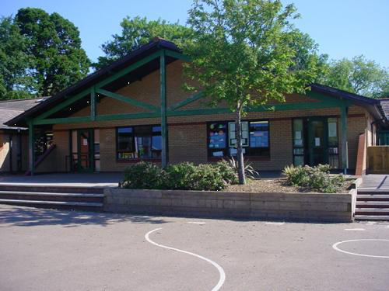

**Focus texts:**

Light and Dark

Can’t You Sleep Little Bear?, Martin Waddell

Space

Astro Girl, Ken Wilson Max

The Way Back Home, Oliver Jeffers

Birds

Puffin Peter, Petr Horacek

Seasonal

Rhinos Don’t Eat Pancakes

***Up High, In The Sky***

**Nursery Enhanced Provision**

**Spring 2020**

**Useful Resources**

[**RSPB Great Bird Watch**](https://www.rspb.org.uk/fun-and-learning/for-teachers/schools-birdwatch/resourcerequestthanks/?utm_source=contact_us&utm_medium=contact_form&utm_content=Email+from+RSPB+website)

**Family Engagement Activities:**

**Spring 1**

Visit to Monmouth Library

**Spring 2, Week 2**

Family cooking / Welsh stay and play – cook Welsh cakes and join in with Welsh activities

**Spring 2, Week 5**

Mother’s Day breakfast / tea. Last 30 mins of session.

Invite our Mums. Give them a card. Give them a cake we have made for them.

**Seasonal Opportunities/themed weeks**

Week 1: Culture Week SPAIN

Week 2

Week 3: Chinese New Year (25th Jan) Year of the Rat

Week 4

Week 5

Week 6

Week 1: Shrove Tuesday (25th Feb) / Welsh Week

Week 2

Week 3

Week 4

Week 5: Mother’s Day

Week 6 STEM Week

Themes:

Week 2 and 3 – Light and Dark / Chinese New Year

Week 4 – 6 – Birds/ Great Bird Watch

Week 1 and 2: Dragons (and Wales)

Week 3 – 6: Space



**Humanities**

Learning about Chinese New Year. Add Chinese resources to home corner eg. Chop sticks

Learning that we live in Wales and about Welsh dragon stories.

Learning that we live on Earth.

Know that we live in Wales and understand some cultural aspects of being Welsh. Leeks and potatoes in the home corner.

**Language, Literacy and Communication**

Creating, retelling and writing our own dragon stories / space travel stories/ afraid of the dark stories.

Writing our names. Forming letters important to us eg m for mummy.

Writing for purpose when collecting data about birds. Creating a class book about garden birds.

Pori, Dori, Stori packs arrive this term. Learn nusery rhymes in Welsh and add these to our rhyme bags.

Phonics – play with sounds eg. Dragon noises,rocket noises. Listen for bird song.

***Up High, In The Sky***

**Nursery Enhanced Provision**

**Spring 2020**

**Health and Wellbeing**

Mother’s Day: Talk about the people we love and why they are important to us.

**Mathematical**

Cooking pancakes and mother’s day cakes.

Sequencing the animals in the Chinese New Year race. Language of first, next, last. Playing races.

Collecting data about birds for the Great British Bird Watch. Tally charts. Writing numbers for meaning/ purpose.

Counting backwards for rocket launching.

Sorting by day/night, by space/earth, birds/other animals, things that can fly/ can’t fly. Classifying birds.

**Science and Technology**

Create a dark cave where children can experience darkness and explore torch light.

Learning to identify common birds by their features. Bird identifying resources in garden.

Describing birds using appropriate vocab eg. feathers, beak, legs, wings.

Understand what birds need to survive the winter and create bird feeders.

Use binoculars.

Learning names of planets. Understanding what stars, moons and planets are. Learning about space travel.

**Expressive Arts**

Chinese fan dancing.

Flamenco dancing.

Dragon art.

Space art.

Listen to Holst’s planet suite. Make our own space music.

Clay birds.

Feather painting/printing/drawings.

Listen to, describe and create bird song.