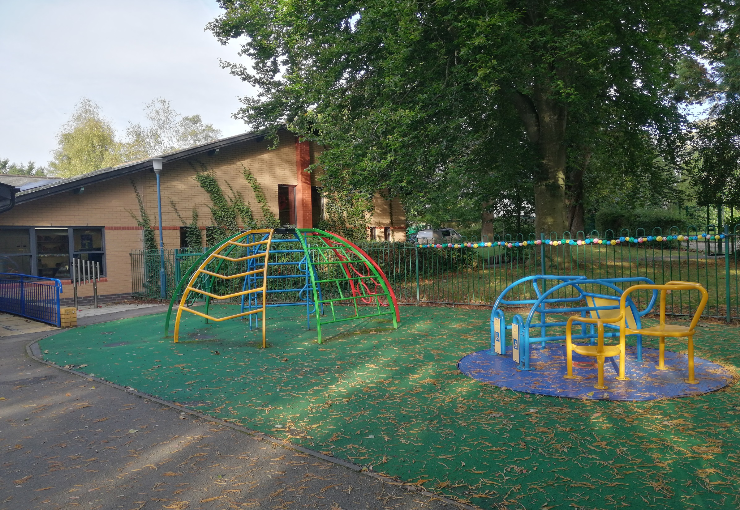

**Maths and Numeracy**

* Grouping and counting sticks
* Matching quantities of sticks to numerals
* Size ordering sticks
* Measuring sticks
* Printing and counting with sticks
* Lollipop stick patterns
* Number formation using lollipop sticks
* Stickle brick construction
* Sorting
* Capacity

**Humanities**

* Experience treasure trail
* Follow a dotted line around a route
* Go on a stick hunt
* Play pooh sticks
* Make nests

***SNRB – Spring 1 2020***

***Stick Man***

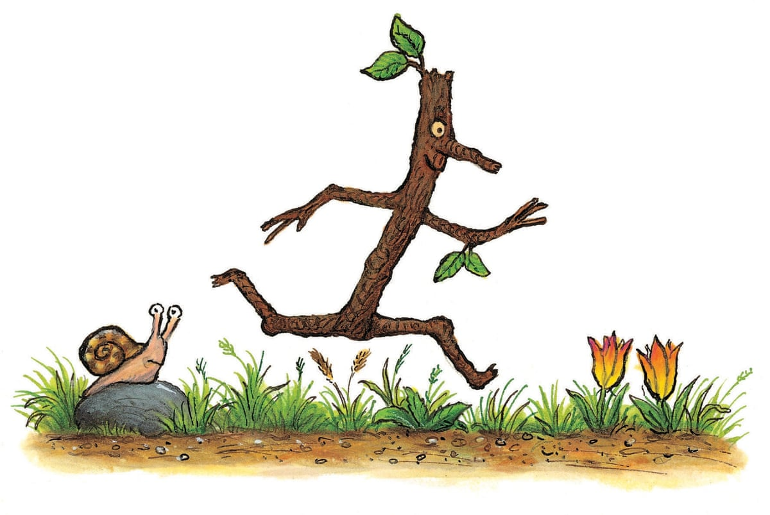

**Expressive Arts**

Make stick people using a variety of materials:

* Matchmakers and a chocolate roll
* Cardboard roll
* Twigs and play-dough
* Pipe cleaners
* Twiglets and a sausage roll
* Celery and salad items

**Welsh**

Greetings throughout the day.

Counting everyday objects to 5.

**Languages, Literacy and Communication**

Text: Stick Man

* Story telling using Total Communication approach
* Rhyme
* Speech sounds
* Sequencing
* Action verbs
* Negatives
* Predicting
* Pronouns
* Matching
* Labelling
* Repetition
* Direct character speech

**Health and Wellbeing**

* Tea Dance, Swimming, Horse Riding, Rebound.
* Begin to explore emotions - look at the Stick Man's facial expressions throughout the story. How is he feeling? Try to make some of those facial expressions too?
* Getting lost/stranger danger.

**Science and Technology**

(Materials and their properties / Scientific Enquiry)

Testing / sorting objects to see if they ‘float’ / ‘do not float’. Make and test:

* Apple boats
* Jam jar lid boats
* Twig raft
* Lollipop stick raft
* Cork boats