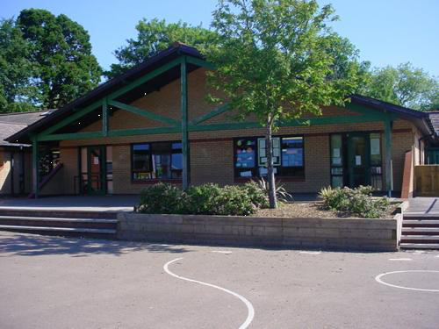

**Welsh**

Learn a range of songs/poems for Eisteddfod

What clothes we wear

What we are doing

Brilliant Betsi

Year 1

**Homework**

1.Be the teacher! Show your family how to wash their hands correctly

2. Create your own delicious or disgusting medicine

3.Draw and label the human body

4. Write facts about people who help us

5.

**Expressive Arts**

Role Play – doctors/hospital  
Learn a range of songs/poems for Eisteddfod  
Paint a picture of an emergency service worker or emergency transport

**Humanities**

Look at a map of the UK and track Betsi’s journey.   
Compare other places to Wales  
SEAL – Getting on and falling out  
Chinese New Year  
Learn about the emergency services

**Health and Wellbeing**

Visit to hospital/talk by health professional. Create questions to ask.

First aider to visit and teach us some basics. Practise on teddies and dolls.

Difference between Victorian hospitals and current day hospitals.

Healthy foods to keep soldiers healthy

**Maths and Numeracy**

Explore capacity and standard measures using medicine spoons, cups, droppers, syringes etc.   
Take our temperatures and record the class results.

Partition and recombine numbers

Use a range of strategies to solve problems

**Science and Technology**

Learn about germs and how they are spread – importance of washing hands.

Write sets of instructions for washing hands.

Safety around medicines – using ICT to create a poster about the dangers

**Language, Literacy and Communication**

Read story of Betsi Cadwaladr and outline her story.

Read Nurse Clementine by Simon James – create a list of items nurses might use.

Talk about how to contact the emergency services . Discuss who they are and what they do.