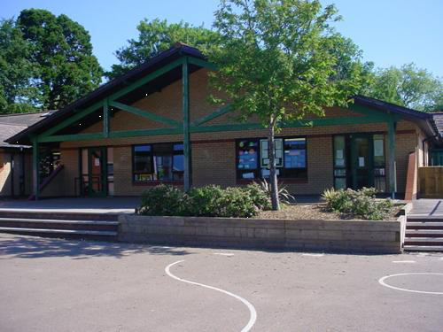

**Maths and Numeracy**

Recite numbers to and beyond 100.

Place value of 2 and 3 digit numbers.

Read, write and order decade numbers to 100.

Compare and order 2 and 3 digit numbers.

Time tables – 2s, 5s and 10s.

Find halves and quarters in practical situations.

Consolidate language of early division.

Understand and use mathematical symbols for addition, subtraction, multiplication and division.

Solve one step / two step word problems.

Use mental recall of number facts to 10 to consolidate bonds of 100 / 1000.

Pay for items up to 20p by anchoring on 10p / find totals from multiples of 10p.

Give change from 10p / give change from multiples of 10p.

**Health and Wellbeing**

Caring about our environment / pollution

Kerb Craft for Year 2’s

Growth Mindset activities

Friendships

PE sessions – indoor and outdoor

Healthy food choices – look at meals and discuss how they could be made healthier

Taste astronaut food. Compare to our food.

**Science and Technology**

Design and make our own kites

Look at different types of weather.

Collect data and record rainfall.

Forces

Weather cycle

Learn about the different planets in our solar system

Rocket experiments

Research how craters are formed

Make fizzy moon rocks

Night and day

Use ICT to create a poster for a missing alien

Record rainfall as a graph using ICT

Weather report – record using ICT using microphone

Begin to record our own voices using an app

**Humanities**

History of astronauts  
The first man on the moon  
Research Tim Peake and look at his vlogs/diaries  
Use Chromebooks to look at live feed from the International Space Station

**Expressive Arts**

Shadow drawing

Umbrella artwork using different techniques

Look at and draw different constellations

Make a telescope to see the stars

Make space slime

Walking in space dances/gymnastics

Create alien music using percussion instruments

Design and make an alien out of clay

Use 2easy and 2simple to animate an alien

**Language, Literacy and Communication**

Reading a selection of fiction and non-fiction books both in class and at home

Information texts about space and astronauts

Read Write Inc. sessions

Writing weather reports

Research about different types of birds

Transport in the sky

Write messages on balloons and release them

Write a list of provisions to take with you into space on a rocket

Write a postcard from space

Make up their own words in an alien language and write their meanings

Write an alien code for a friend to solve.

Instructions for a rocket launch

***Way Up High in the Sky***

***YEAR R/1/2***