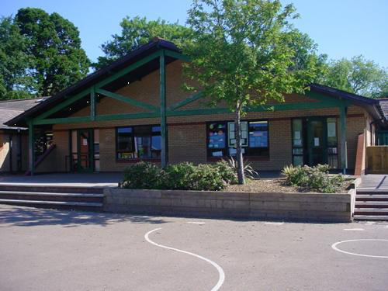

**Develop**

Make a booklet containing photos and captions of the obstacle course.

Teamwork games.

Keep fit sessions daily

**Science Investigations**

**PE**

Become proficient at basic travelling actions. Describe what happens to their breathing after exercise. Develop gross motor skills. Understand rules and play simple competitive games. Solve problems with a partner.

**Express**

Share individual photos with child dicatated captions.

**Engage**

Create and participate in a garden obstacle course and video session.

**RE/SEAL**

Value learning and success of themselves and other people.

**Literacy**

Oracy – retell and event or experience. Use new vocabulary in play, Recognise rhythm and rhyme. Follow simple action songs. Follow simple instructions. Speak clearly enough to be understood by adults.

Writing – Attribute meaning to marks.

**Welsh**

Register and following commands.

Numbers to 5

**How High Can I Jump?**

**Nursery Summer 1**

**Innovate – Let’s get creative!**

Plan a Sports Day session for parents to attend after the half term break.

**Homework**

**Numeracy**

Listen to and join in with songs, rhymes, games and stories that have a mathematical theme.

Transfer mathematical skills to play