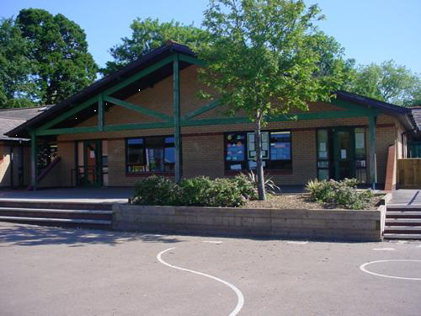
Literacy
RWI sessions: Daily phonics, reading and letter formation
Non-fiction books, leaflets, travel brochures and maps of Cardiff.
Share Roald Dahl stories – Esio Trot, Fantastic Mr. Fox, Boy, (a Cardiff author).
Recount of trip to Cardiff Castle.
Develop
Learn about the Animal Wall at Cardiff Castle and make our own model animal wall.
Dig for artefacts in the sand.
Role play – Welsh souvenir shop, make lovespoons, flags and model Welsh cakes.
Billy the Seal – story and song – How Cardiff has changed over time.
Cardiff Bay.- tuff spots small world play.
Shoe box garden/park.
ICT – Superimpose yourself onto a Cardiff background.

Numeracy
Recite to 30 and beyond. Count in tens to 100. Begin to compare and order to 10 and beyond.
Counting a collection up to 20.
Stories of 8 and 9.
Grouping – early multiplication language
Recall one more/less within 10.
Addition/subtraction within 10.
Estimate and check by counting.
Use different combinations of coins to 10p.
Express
Talk about our favourite feature of Cardiff giving our reasons for our thinking.
Innovate – Let’s get creative!
Make posters to advertise Cardiff
Consider Millennium Stadium, Cardiff Castle, City Hall, National Museum, Norwegian Church and Arts Centre, Wales Milennium Centre.
Cardiff Tales - Reception

Homework
Paint a picture of Cardiff Castle.
Take a day trip to Cardiff to visit a significant building or landmark.
Make a scrap book about Cardiff and fill it with interesting information.
Find the names of Welsh cities and record on a map in English and Welsh.

Science Investigations

Engage
Memorable Experience: Visit Cardiff Castle on 9th May. Take digital photos of different areas and interesting features. Meet with the Knight of the Castle and learn about armour and weapons. Take a guided tour and participate in a workshop about Castle Life.
Find out about life in Cardiff. Look at positional language, coordinates and features of maps. Learn about significant buildings and landmarks in Cardiff. Compare modern/old buildings. Draw pictures of our favourite building. Skype a classroom in Cardiff and compare with ours.

Welsh
Hwyl Dan 7 – Pecyn Melyn, Glas, Gwyrdd.
PE
Sports Day preparation.
Medieval Dancing.
Yr 2 Swimming.
RE/SEAL
Keeping safe, Reverend Greeves assembly, Reverend Janet assembly.

