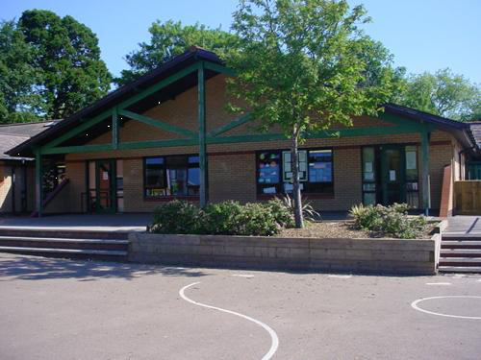

**Maths and Numeracy**

Pay for items up to 20p / Position amounts of money up to £1 and link with place value cards and coins

Order a set of numbers within 20 / Round 2 digit numbers to the nearest 10p on a number line

Compare items which are the most/least expensive

Read and write numbers to 20/Read and write number words to 100

Practise bonds within 10

Practise bonds of 4 & 5/ Bonds of 6, 7, 8 and 9.

Use language of early multiplication / Build multiplication facts for the x2 table using repeated addition.

Add/subtract two numbers within 20/ Use mental recall of number facts to 10 and place value to add or subtract larger numbers

**Welsh**

Write a list of things they like/don’t like – Dwi’n hoffi …/dw I ddim yn hoffi…

Paragraphs about themselves as a super herto

Write a letter to Sion Corn

Ask question sawl un sy’n hoffi? Create graphs

Ble mae…? Using prepositions to extend answers

**Homework**

**Plan or make a lunchbox for a superhero**

**Who is your hero? Bring a picture of them to school and explain why.**

**Make a table of traits comparing a villain with a good guy.**

**If you could have s upper power what would it be and why?**

**Make a model of a superhero**

**Write likes and dislikes of a superhero in Welsh. Start with Dw I’n hoffi…, dw I ddim yn hoffi…**

**Science and Technology**

Learn about keeping safe when using the web

Use Internet search engines to ‘follow’ real life heroes.

Investigate superhero skills in the class. Who is the fastest, most flexible; whose hand is the steadiest?

Identify whether a clothing colour affects your opinion of a character?

Secret codes and plans

Graphics and designs for comics

**Language, Literacy and Communication**

Make a list of words to describe a superhero – What is your favourite and explain why?

Look at a range of comic strip-style superhero stories

Use picture comic strip and blank speech and thought bubbles

Tell a short story about superheroes and villains

Invite a real life hero into school – Emergency services

Write fantasy stories and list WOW words.

News reports and information leaflets

Develop sentences about ‘Super selves’

Read and make simple fact files

Secret identities and super hero cards

**Health and Wellbeing**

Look at superheroes in different poses, imitate these poses and take photos.

Move like a superhero – create simple sequences

Communicate good and bad, right and wrong

Play superhero games

Carry out a superhero rescue

Trials and obstacles

**Superheroes**

**Year 1 & 2**

**Memorable Experience – Superhero Hunt**

**Expressive Arts**

In groups, experiment with percussion to create imaginative sound effects for superheroes

Match actions with the sounds they have recorded to make dance motifs

Create a slow motion conflict sequence

Draw an illustration of their favourite superhero

Make superhero masks

Design a new superhero and design a costume, name, super powers, etc.

Posters and advert designs

Making slime

**Humanities**

What does hero mean? Qualities of real life heroes

Learn about some real life heroes

Listen to the story of a historical superhero such as Rosa parks, Emily Davison, Mary Seacole, Elizabeth Fry.

Investigate amazing scenes and how they help them in every day life.

Explore numbered mystery boxes. Discuss senses to identify what is in the box