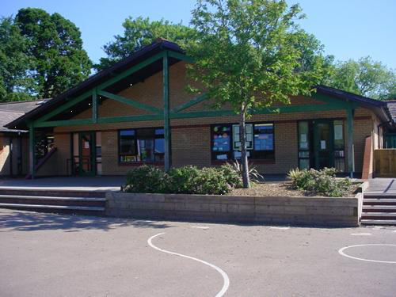

**Humanities**

**WM1:** developing an inquiring mind enables learners to explore and investigate the world past, present and future for themselves.   
**WM2:** Events and human experiences are complex and are perceived, interpreted and represented in different ways. **LNF**  
2.OL3, 2.OC2, 2.RS3, 2.RA3, 2.WM1, 2.WS2, 2.D2, FP2, FP5, FP6, FP18, FP19, 2.N1,   
**DCF**  
Collaboration  
Storing and sharing

**Health and Wellbeing**

**WM3:** How we engage with different social influences shapes who we are and our health and well-being.   
**WM4:** healthy relationships are fundamental to our sense of belonging and well-being.

**LNF**

2.OC2, 2.RS3, 2.RA3, 2.WM1, 2.WS2, FP2,FP5, FP6, FP18, FP19, 2.N1

**DCF**

Health and wellbeing

Digital rights, licensing and ownership

**Science and Technology**

**National Curriculum**

**WM1:** Being curious and searching for answers help further our understanding of the natural world and helps society progress.

**WM2:** Design, thinking and engineering, are technical and creative endeavors intended to meet society’s needs and wants.

**WM 3:** The world around us is full of living things which depend on each other for survival.

**LNF**

FP2, FP5, FP6, FP11, FP12, FP17, FP19, 2M8, 2.D2, 2.OS4, 2.OL3, 2.OC1, 2.RS6, 2.WM2

**DCF**

Problem solving and modelling

Data and information literacy

**Expressive Arts**

**WM2:** Responding and reflecting both as artists and audience is a fundamental part of learning about and through the expressive arts.

**WM3:** Creative work combines knowledge and skills using the senses, inspiration and imagination.

**LNF**

2.OL3, 2.OC2, 2.RS3, 2.RA3, 2.WM1, 2.WS2, 2.M9, 2.N17, FP2, FP5, FP6, FP18, FP19, 2.N1

**DCF**

Collaboration

Storing and sharing

**Language, Literacy and Communication**

**WM2**: Learners who listen and read effectively are prepared to learn throughout their lives.

**WM3**: Learners who speak and write effectively are prepared to play a full part in life and work.

**WM4**: Literature fires imagination and inspires creativity.

**WM5**: Learners who listen and read effectively are prepared to learn throughout their lives.

**WM6:** Learners who speak and write effectively are prepared to learn throughout their lives.

**LNF**

1.OS1, 2.OS1, 1.OS2, 2.OS3, 2.OS4, 2.OS5, 2.L1, 2.OL3, 2.OL4, 2.OC1, 2.OC2, 2.RS1, 2.RS2, 2.RS3

2.WM1, 2.WM2, 2.WM3, 2.WM5

**DCF**

Storing and sharing, planning, sourcing and searching

Creating and evaluating and improving

**Maths and Numeracy**

**WM1**: The number system is used to represent and compare relationships between numbers and quantities.

**WM3**: Geometry, focusses on relationships involving properties of shape, space and position and measurement focuses on quantifying phenomena in the physical world.

**LNF**

FP1, FP2, FP3, FP4, FP5, FP6, FP11, FP17, FP19, 2.N2, 2.N3, 2.N4, 2.N5, 2.N12, 2.N16, 2.N17, 2.M1,

**DCF**

Problem solving and modelling

Data and information literacy

***TELL ME A STORY***

***YEAR 1/2***