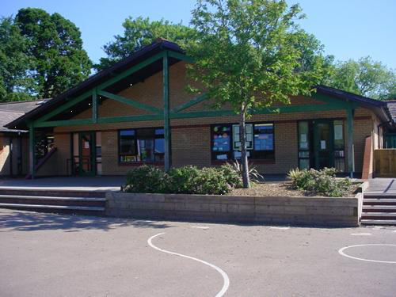

Rio de Vida

Year 1  
**Memorable Experience –**

**Samba band workshop 16.05.18**

**Welsh**

Prepositions  
Ask where something is  
To ask/respond to ‘what would you like?’

Role play Doctors surgery

**Homework**

1.Design and create your own bright & colourful carnival outfit

2. Write ‘Amazing Rio’ facts

3. Find out about Brazil’s exotic animals

4. Say what we like/don’t like in Welsh

**Expressive Arts**

Memorable Experience – ‘Brazilian Carnival Day’  
Drawing – Victoria Regia water lily  
Expore percussion instruments and Samba music  
Colour and texture through collage  
Use coloured feathers to make a headdress

**Humanities**

Locate Brazil on a world map

Flags from different countries

National anthems

Compare Rio Carnival to Notting Hill

Celebrations and seasons

**Health and Wellbeing**

Football skills

Sports day/Mini Olympic day (5.6.18)

Carnival music and dancing

SEAL – Changes (new class visits)

Understanding my feelings/understanding the feelings of others

**Maths and Numeracy**

Language of early multiplication

Recognise and understand odd and even numbers

Estimate measurements in non-standard measures

Combinations of money to pay for items to 20p

**Science and Technology**

Recipes for a range of street food and carnival food

Wind Experiment with ribbons and feathers

Celebratory cakes – instructions

Forces – pulling and pushing

ICT – posters and leaflets

**Language, Literacy and Communication**

Talk and write about carnival experience

Discuss alliteration such as ‘fabulous floats’ or ‘fluttering feathers’

Brazilian legends and mythology – Victoria Regia/ Guaranare

Create own mythical creature

Greetings and phrases in Portuguese