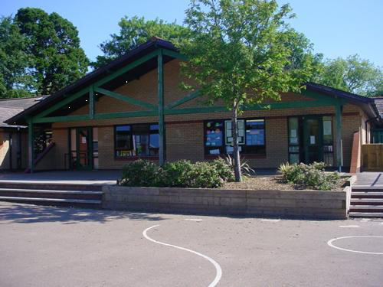

**Homework**

Design and create your own bright and colourful carnival outfit – Wear to begin our topic.

Write ’Amazing Rio Facts’

Find out about some more of Brazil’s exotic birds and animals

Find out about some famous Brazilian sports stars

Explain in Welsh their likes/dislikes

**Health and Wellbeing**

Football skills

Mini Olympic day/Sports day (5/6/18)

Carnival music and dancing

SEAL – Changes (new class visits)

Understanding my feelings/understanding the feelings of others

Food – Nutrition

**Expressive Arts**

Memorable Experience – ‘Brazilian Carnival Day’

Drawing – Victoria Regia water lily

Explore a range of percussion instruments – Samba music

Colour and texture through collage

Use coloured feathers to make a headdress

**Language, Literacy and Communication**

Talk and write about carnival experience

Discuss alliteration such as ‘fabulous floats’ or ‘fluttering feathers’

Carnival Poetry/non-fiction (football)

Brazilian legends and mythology – Victoria Regia/Guaranare

Create own mythical creature

Greetings and phrases in Portuguese

**Humanities**

Locate Brazil on a World map

Flags from different countries

National Anthems/tourist adverts

Compare Rio carnival to Notting hill

Celebrations and seasons

**Welsh**

Read a story/act out a script

Role-play ‘Ar y bws’

Telling the time – words and pictures

Read and order calendars

Rio de Vida

Year 2

**Maths and Numeracy**

2d shapes and repeated patterns

Count on in 2ps, 5ps and 10ps

Position and order 3-digit numbers

Make connections with measures and money – Find totals and give change

Doubles of multiples of 10

Multiplication facts x3

**Science and Technology**

Recipes for a range of street food and carnival food

Wind Experiment with ribbons and feathers

Celebratory cakes – Instructions

Forces - Pulling and pushing

ICT – Posters and leaflets