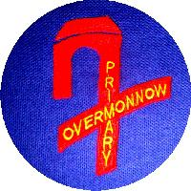

**Overmonnow Primary School**

*PARENTAL NOMINATION FORM FOR MORE ABLE AND TALENTED PUPILS*

At Overmonnow Primary School we aim to fulfil the potential of all children. We are keen to develop our recognition and provision for more able and talented pupils in academic, leadership, organizational, physical, social, artistic and musical skills.

We are conscious that many of our pupils win prestigious awards for pursuits outside school and, if at all possible, we would wish to support these children in school. We are also aware that there may be many children achieving very high standards in a variety of activities about which we know very little, or sometimes nothing.

We at Overmonnow believe that more able and talented pupils are those who are more able than their peers across the curriculum as well as those who show a talent in one or more specific area; and who require opportunities for enrichment and extension that go beyond those provided for the general cohort of pupils.

If you feel that your child has demonstrated signs of advanced skills in any of these areas please fill in the form attached and return it to your child’s teacher.

Child’s Name:_____________________ Year:_______ Date:_____________________

|  |  |
| --- | --- |
| AREA OF DEVELOPMENT | EXAMPLES/COMMENT |
| My child shows particular flair in: |  |