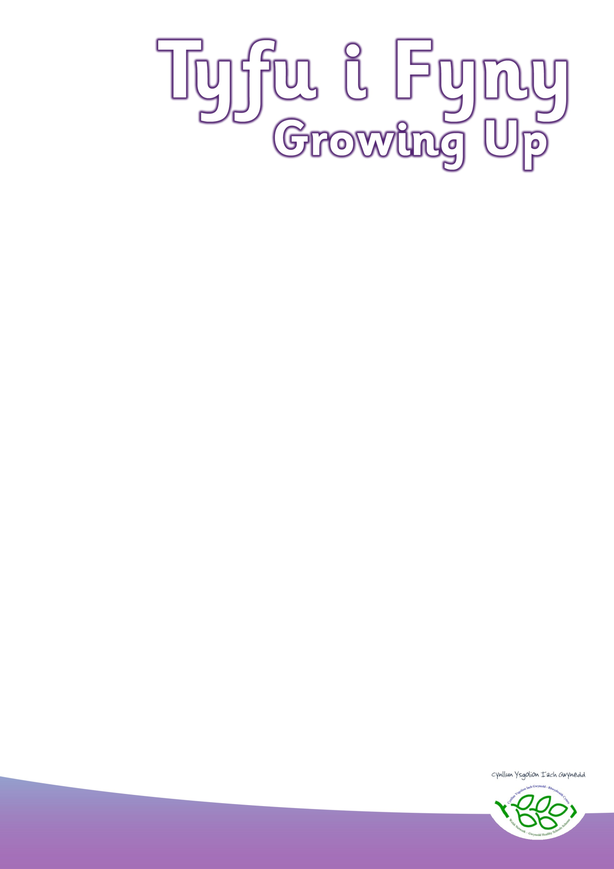
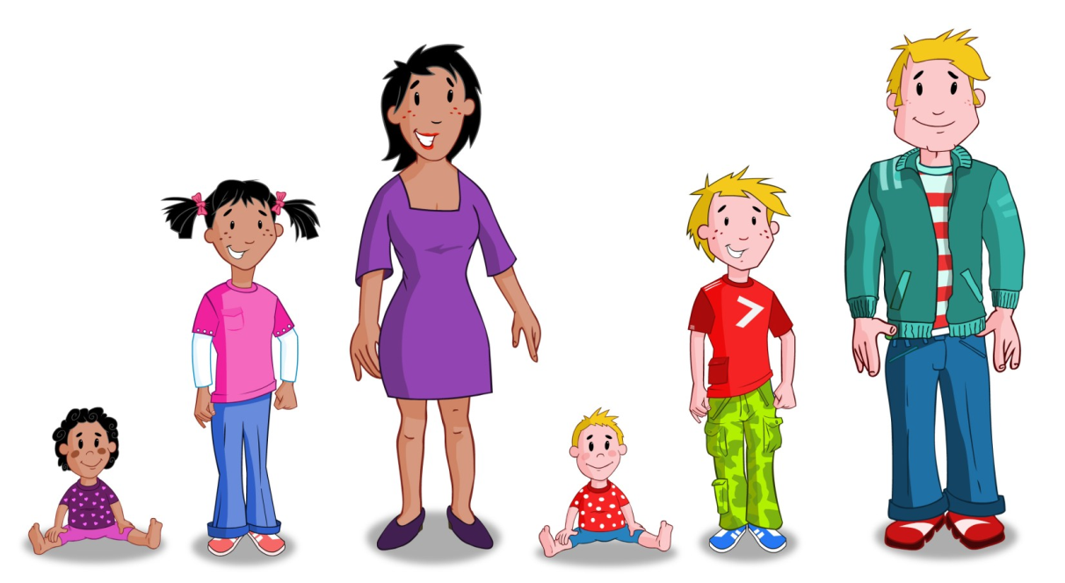
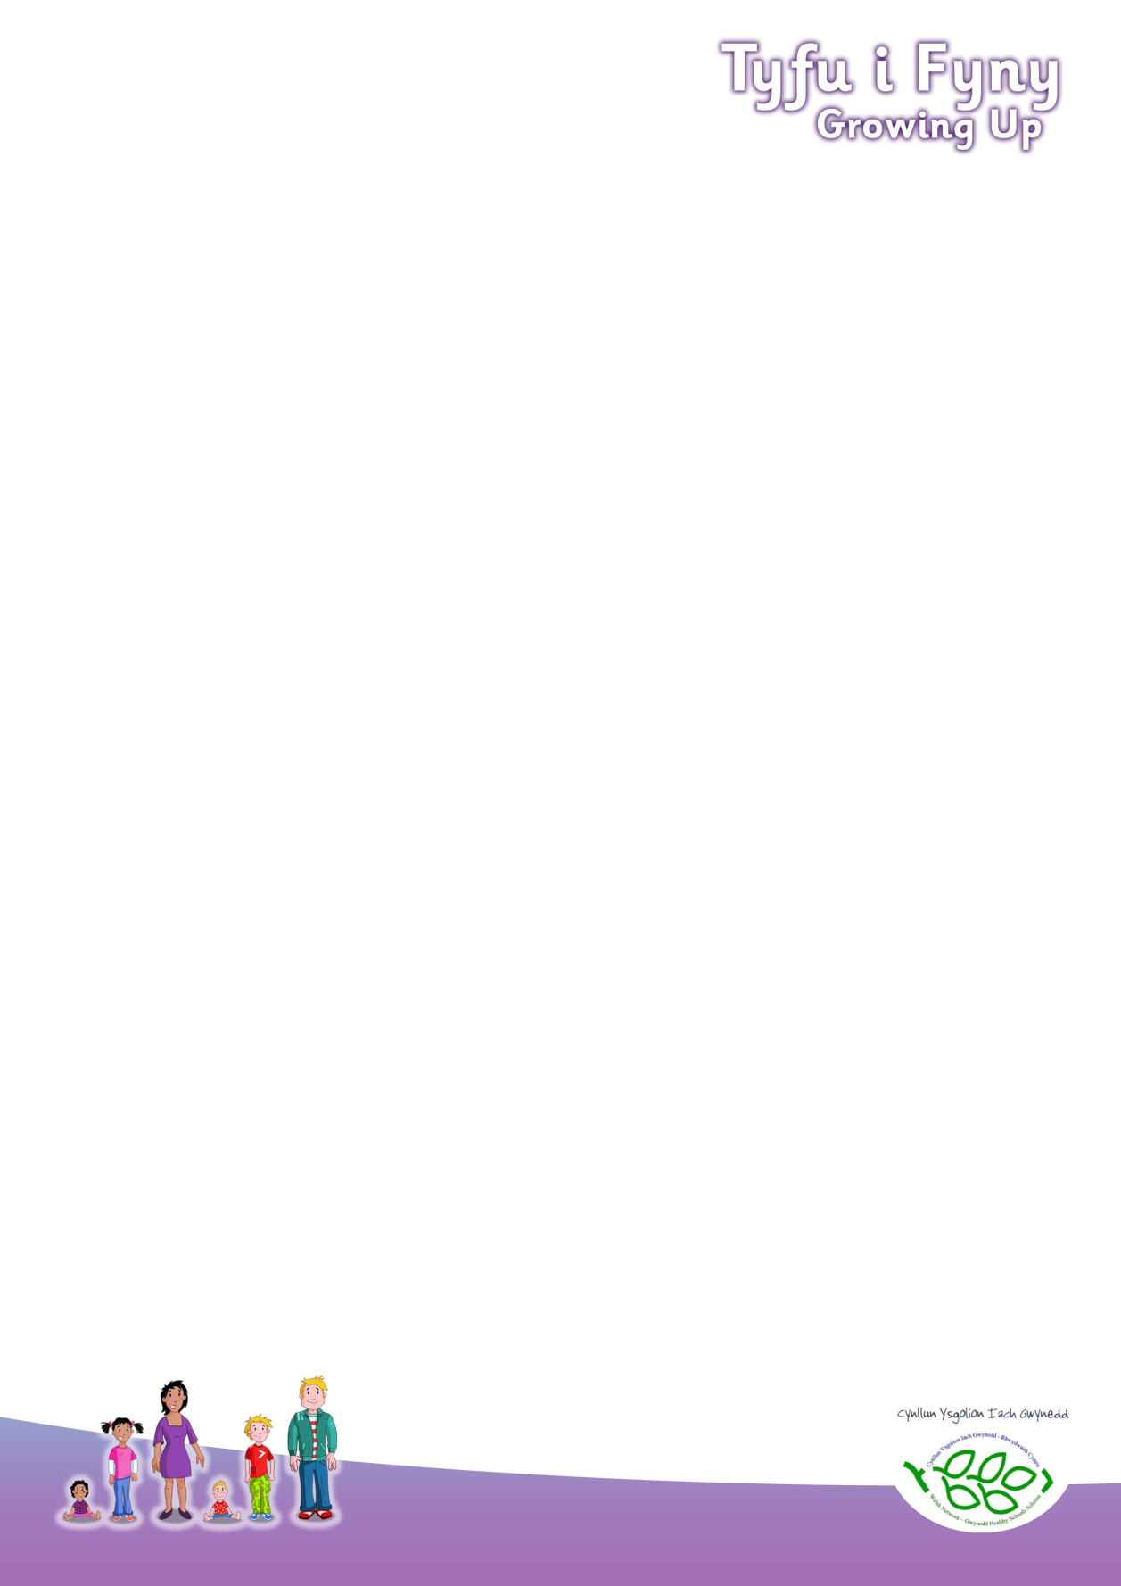

Learning Outcomes Years 5/6

Following a series of lessons pupils will:

Understand the reasons for the physical and emotional changes which take place during puberty, including conception, pregnancy and birth.
Understand the range of their own and others’ feelings and emotions.
Know what to do or who to turn to when they are not feeling safe.

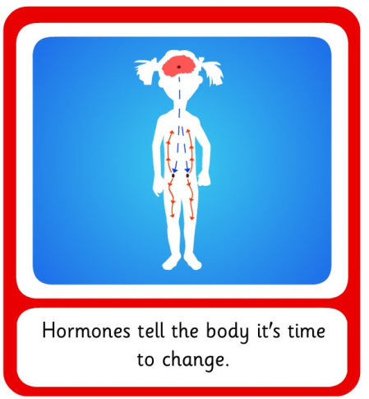
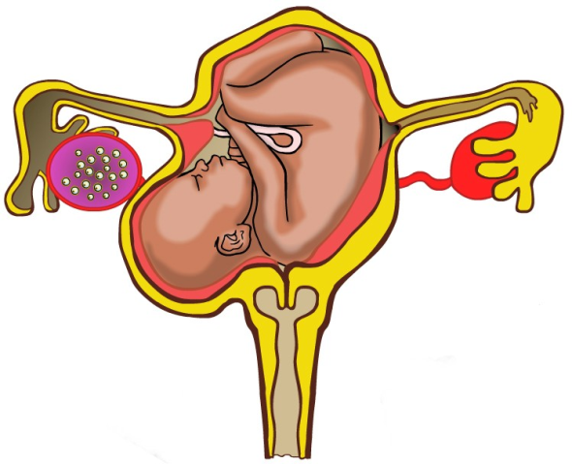

Personal Development
and Relationships

Information booklet for parents

If you wish to see a copy of the school’s policy or any of the resources or for more information you are welcome to contact the school.
Reproduced with thanks from Gwynedd Healthy Schools Scheme

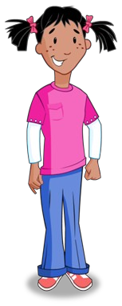

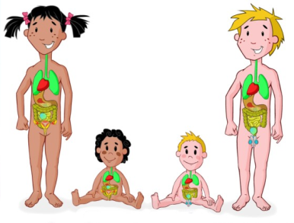
Learning Outcomes for the Foundation Phase

By the end of year 2 pupils will be able to:

Differentiate between appropriate and inappropriate touching.
Use the correct words to name parts of the body in order to differentiate between male and female. The terms we will be using are penis (pidyn) and testicles (ceilliau) for males and breasts (bronnau) and vagina (fagina) for females.

Learning Outcomes Years 3/4

Following a series of lessons pupils will:

Understand the importance of their personal safety.
Understand what to do or to whom to go when feeling unsafe.
Take increasing responsibility for keeping the
mind and body safe and healthy.
Value families and friends as a source of mutual support.
Develop respect for themselves and others.
Understand how cultural and religious beliefs can affect the way people think.
Respect differences and acknowledge the importance of equal opportunities.

Our school is taking part in the Monmouthshire Healthy Schools Scheme. As part of this work we would like to share with you our Personal Development and Relationships Education.

The purpose of this booklet is to provide you with information on what will be introduced to the children.

Personal Development Relationships will be introduced to pupils through:

Circle time activities;
Gwynedd Healthy Schools ‘Growing Up’ resources;
Sense Resource ‘Growing Up and Keeping Safe’;
Story books;
Curriculum subjects e.g. Science, Religious Education,
Personal and Social Education programs and
Informally as opportunities arise in the classroom.



